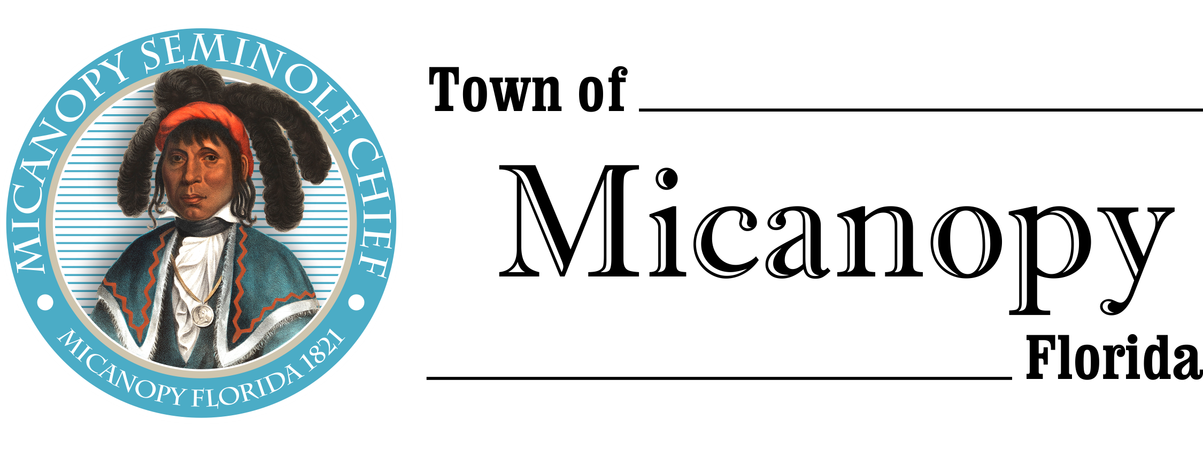
Town of Micanopy
Town Commission • Final Millage/Budget Hearing
Tuesday • September 28, 2020 • 6:00 PM
_____________________________________________________________________________________________

A G E N D A
THE TOWN OF MICANOPY WILL REQUIRE ALL ATTENDEES TO WEAR A FACE MASK. SOCIAL DISTANCING AND ALACHUA COUNTY HEALTH SAFETY GUIDELINES WILL BE FOLLOWED.

- Call to Order

- Invocation & Pledge of Allegiance to Flag

- Roll call

- Agenda Approval

- Open Public Hearing

- Mayor announces Final Millage Rate and Reads Resolution 2020- :
- The F/Y 2020/2021 millage rate is 5.5260 mills, which is the rollback rate

- Motion to Accept Final Millage Rate

- Mayor and Town Commission Comment on F/Y 2020/2021 Final Millage Rate

- Public Comment on F/Y 2020/2021 Final Millage Rate

- Commission Vote on Resolution 2020- Setting Final Millage Rate at 5.5260

- Overview of F/Y 2020/2021 Final Budget and Read Resolution 2020- :
- Setting Final Revenue and Appropriations in the Amount of $1,

- Motion to Accept Final Budget

- Mayor and Town Commission Comment on F/Y 2020/2021 Final Budget

- Public Comment on F/Y 2020/2021 Final Budget

- Commission Vote on Resolution 2020- Setting the Final Budget for F/Y 2020/2021

- Close Public Hearing

- Adjourn

PLEASE NOTE: PURSUANT TO SECTION 286.015, FLORIDA STATUTES, IF A PERSON DECIDES TO APPEAL ANY DECISION MADE BY THE COMMISSION WITH RESPECT TO ANY MATTER CONSIDERED DURING THIS MEETING, HE OR SHE WILL NEED TO ENSURE THAT A VERBATIM RECORD OF THE PROCEEDINGS IS MADE, WHICH RECORD INCLUDES THE TESTIMONY AND EVIDENCE UPON WHICH THE APPEAL IS TO BE BASED. IN ACCORDANCE WITH THE AMERICAN WITH DISABILITIES ACT, A PERSON WITH DISABILITIES NEEDING ANY SPECIAL ACCOMODATIONS TO PARTICIPATE IN TOWN MEETINGS SHOULD CONTACT THE TOWN ADMINISTRATOR, 706 NE CHOLOKKA BLVD., MICANOPY, FLORIDA 32667-0137, TELEPHONE (352) 466-3121.
_____________________________________________________________________________________________

