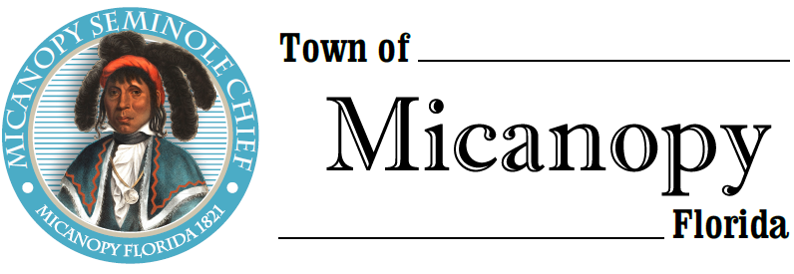
Town of Micanopy
Town Commission • Tentative Millage/Budget Hearing
Monday • September 14, 2020 • 6:00 PM

A G E N D A
THE TOWN OF MICANOPY WILL REQUIRE ALL ATTENDEES TO WEAR A FACE MASK. SOCIAL DISTANCING AND ALACHUA COUNTY HEALTH SAFETY GUIDELINES WILL BE FOLLOWED.

- Call to Order

- Invocation & Pledge of Allegiance to Flag

- Roll call

- Agenda Approval

- Open Public Hearing

- Mayor announces Tentative Millage Rate and Reads Resolution 2020-05:
- The F/Y 2020/2021 millage rate is 5.5260 mills, which is the rollback rate

- Motion to Accept Tentative Millage Rate

- Mayor and Town Commission Comment on F/Y 2020/2021Tentative Millage Rate

- Public Comment on F/Y 2020/2021 Tentative Millage Rate

- Commission Vote on Resolution 2020-05 Setting Tentative Millage Rate at 5.5260

- Overview of F/Y 2020/2021 Tentative Budget and Read Resolution 2020-06:
- Setting Tentative Revenue and Appropriations in the Amount of $1,

- Motion to Accept Tentative Budget

- Mayor and Town Commission Comment on F/Y 2020/2021 Tentative Budget

- Public Comment on F/Y 2020/2021 Tentative Budget

- Commission Vote on Resolution 2020-06 Setting the Tentative Budget for F/Y 2020/2021

- Announce:
The Second Fiscal Year 2020/2021 Millage Rate & Budget Hearing setting the Final Millage Rate and Final Budget for Fiscal Year 2020/2021 will be held on Monday, September 28, 2020 at 6:00 pm in the Activity Room at Micanopy Town Hall, 706 NE Cholokka Blvd., Micanopy, Florida 32667.

- Close Public Hearing

- Adjourn

PLEASE NOTE: PURSUANT TO SECTION 286.015, FLORIDA STATUTES, IF A PERSON DECIDES TO APPEAL ANY DECISION MADE BY THE COMMISSION WITH RESPECT TO ANY MATTER CONSIDERED DURING THIS MEETING, HE OR SHE WILL NEED TO ENSURE THAT A VERBATIM RECORD OF THE PROCEEDINGS IS MADE, WHICH RECORD INCLUDES THE TESTIMONY AND EVIDENCE UPON WHICH THE APPEAL IS TO BE BASED. IN ACCORDANCE WITH THE AMERICAN WITH DISABILITIES ACT, A PERSON WITH DISABILITIES NEEDING ANY SPECIAL ACCOMODATIONS TO PARTICIPATE IN TOWN MEETINGS SHOULD CONTACT THE TOWN ADMINISTRATOR, 706 NE CHOLOKKA BLVD., MICANOPY, FLORIDA 32667-0137, TELEPHONE (352) 466-3121.

