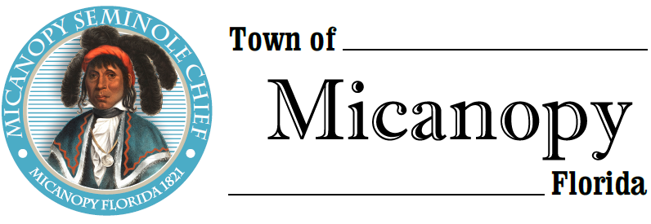
Town of Micanopy
Town Commission • Regularly Scheduled Meeting
Tuesday • April 13, 2021 • 7:00 PM
_________________________________________________________________________________
A G E N D A
THE TOWN OF MICANOPY WILL REQUIRE ALL ATTENDEES TO WEAR A FACE MASK. SOCIAL DISTANCING AND ALACHUA COUNTY HEALTH SAFETY GUIDELINES WILL BE FOLLOWED.
1. Call to Order

2. Invocation & Pledge of Allegiance to Flag

3. Roll Call

4. Consent Agenda
A) Agenda Approval
B) Minutes of Regular Board Meeting of March 9, 2021 and Special Dollar General Stakeholder Meeting of April 6, 2021
C) Review & Acceptance of Financial Transactions & Reports

5. Guests
A) Lena McNeer, Alachua County Library District

6. Citizen’s Forum – Public Comment (public comments limited to 5 minutes per speaker, please)

7. Citizen Board and Committee Reports
A) Planning & Historic Preservation Board
B) Tree Committee

8. Town Attorney Report
A) Final Reading Ordinance 2021-01 Vacating Hirsch Road Right-of-Way
B) Resolution 2021-02 Opposition to Pre-exemption of Home Rule
C) Facility Use Application
D) Proposed Charter Changes

9. Town Administrator Report

10. New Business
A) Proclamation: Declaring April as Water Conservation Month
B) Sale of Town’s Silverado Diesel Flatbed Truck
C) Great American Cleanup – Saturday, April 24th
D) Speed Spy Traffic Study

11. Unfinished Business
A) Bicentennial Celebration – Pole Decorations
B) Town Administrator Position Applicants
C) Dollar General Stakeholders Meeting

12. Town Commissioner Reports
• Commissioner (Seat 2) Tim Parker • Commissioner (Seat 3) Ginny Mance
• Commissioner (Seat 4) Troy Blakely • Commissioner (Seat 5) Mike Roberts

13. Mayor (Seat 1) Joe Aufmuth Report

14. Adjourn

PLEASE NOTE: PURSUANT TO SECTION 286.015, FLORIDA STATUTES, IF A PERSON DECIDES TO APPEAL ANY DECISION MADE BY THE COMMISSION WITH RESPECT TO ANY MATTER CONSIDERED DURING THIS MEETING, HE OR SHE WILL NEED TO ENSURE THAT A VERBATIM RECORD OF THE PROCEEDINGS IS MADE, WHICH RECORD INCLUDES THE TESTIMONY AND EVIDENCE UPON WHICH THE APPEAL IS TO BE BASED. IN ACCORDANCE WITH THE AMERICAN WITH DISABILITIES ACT, A PERSON WITH DISABILITIES NEEDING ANY SPECIAL ACCOMODATIONS TO PARTICIPATE IN TOWN MEETINGS SHOULD CONTACT THE TOWN ADMINISTRATOR, 706 NE CHOLOKKA BLVD., MICANOPY, FLORIDA 32667-0137, TELEPHONE (352) 466-3121.

