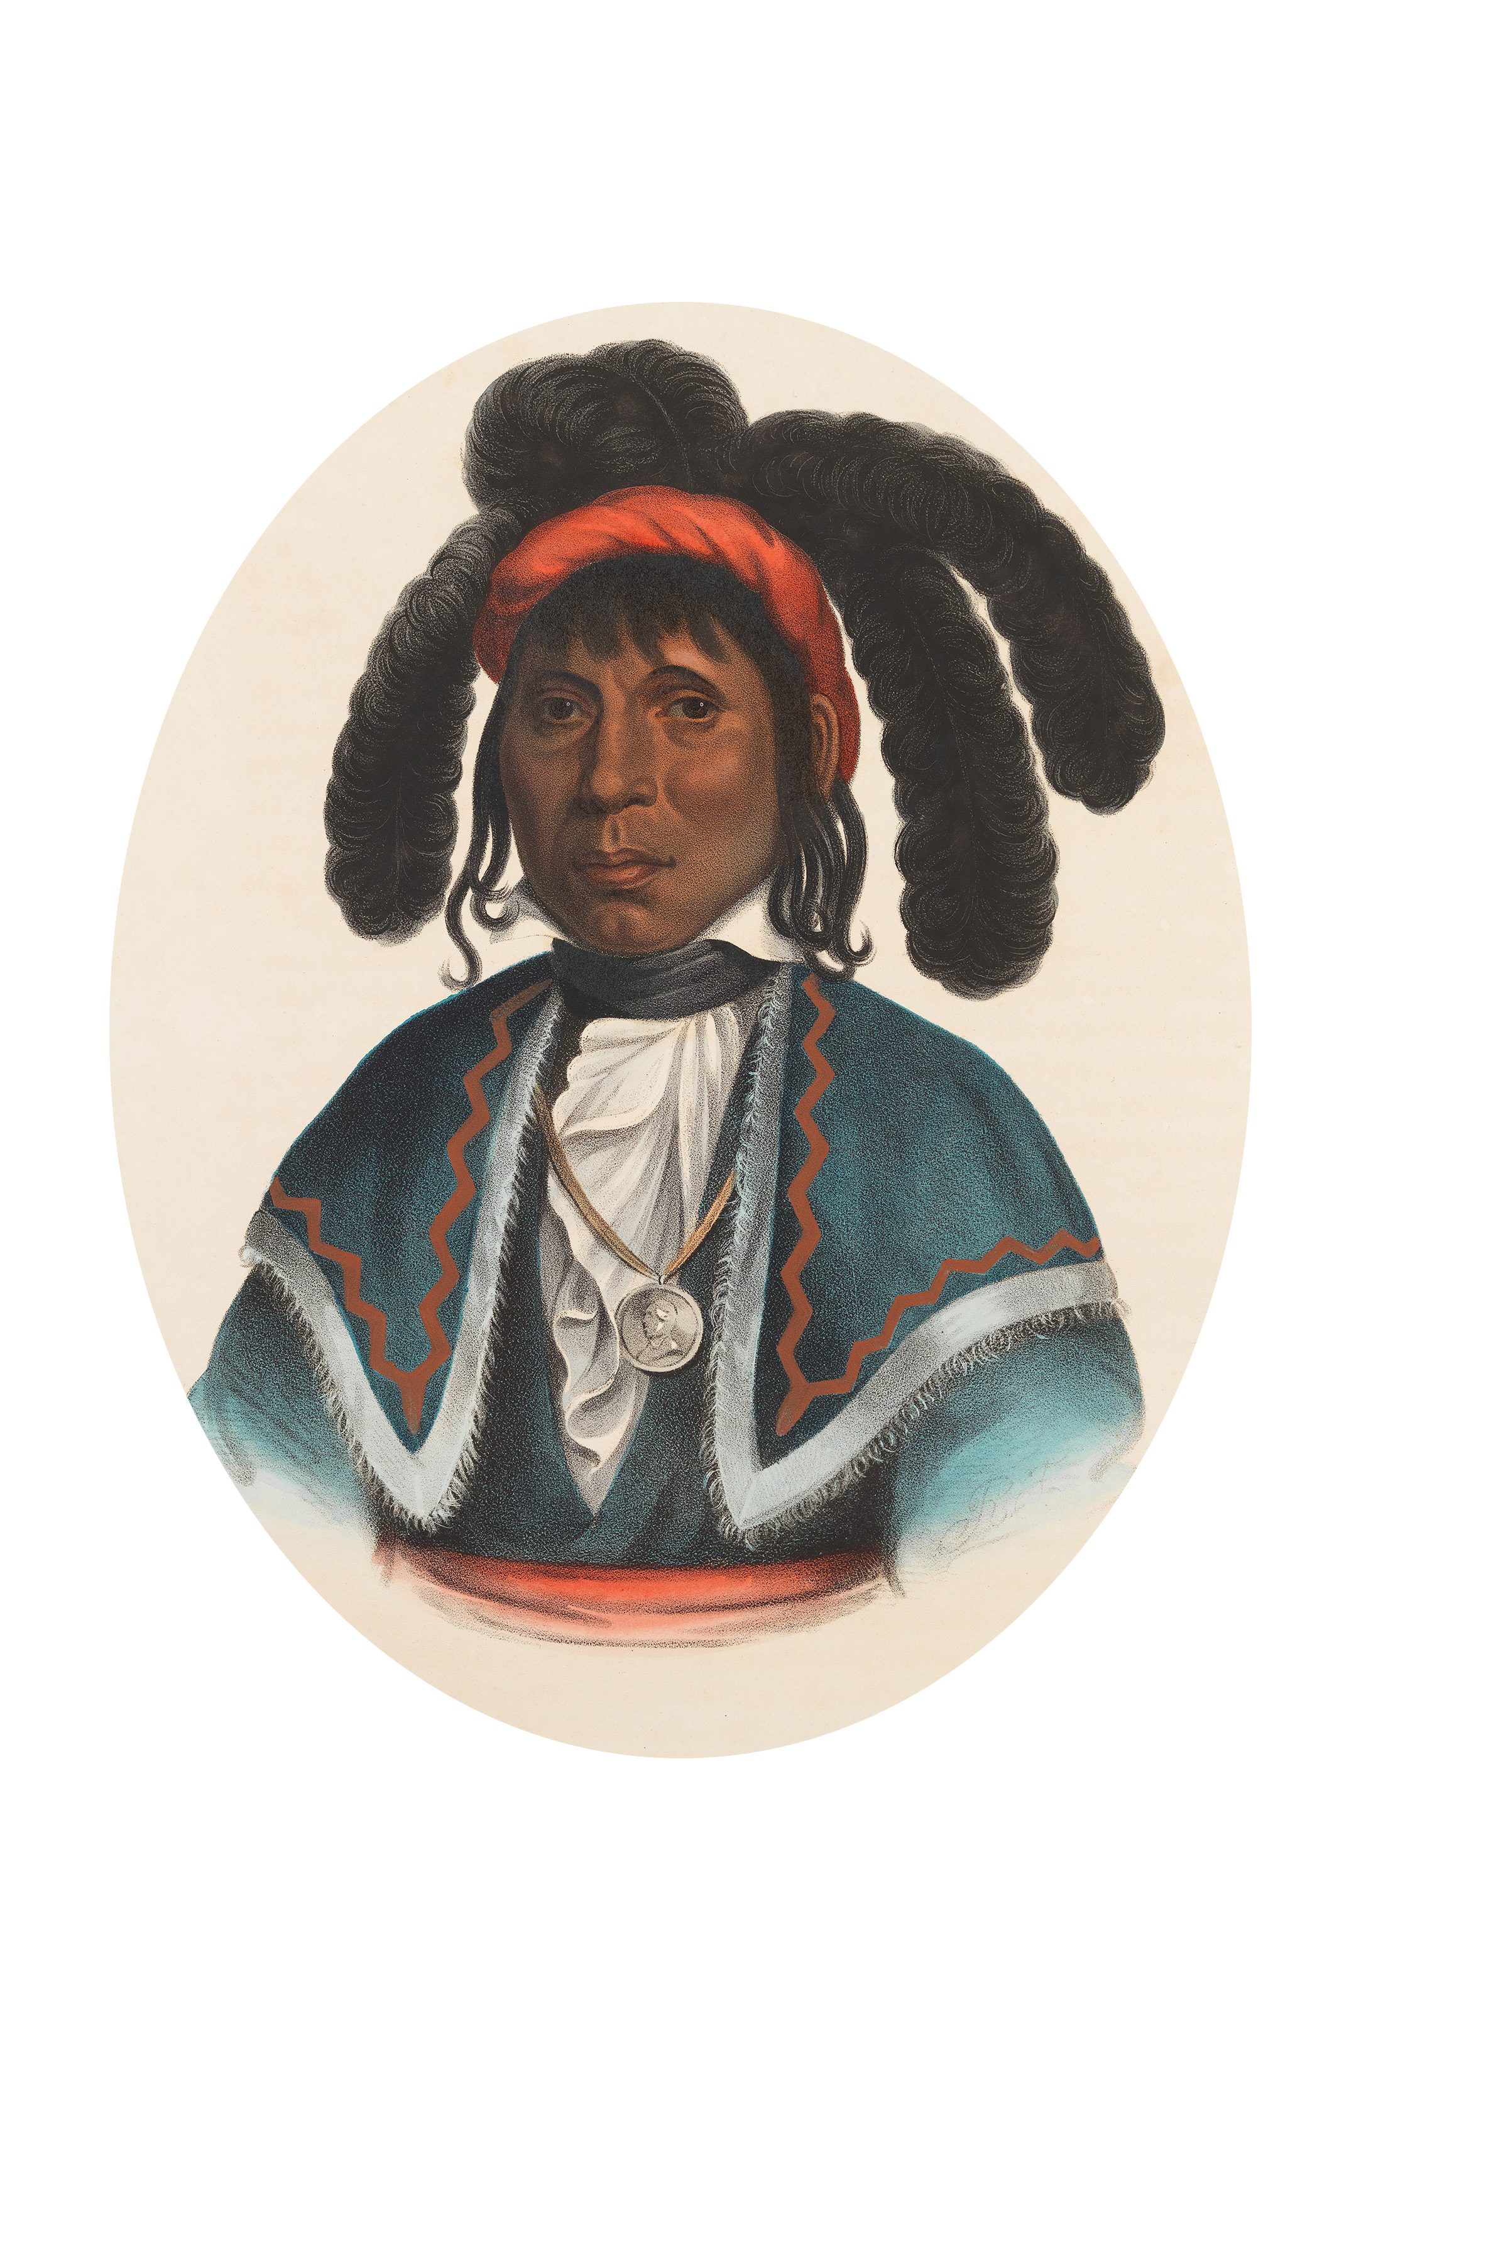

Town of Micanopy
Town Commission • Regularly Scheduled Meeting
Tuesday • April 9, 2019 • 7:30 PM
MICANOPY, SEMINOLE CHIEF

A G E N D A

- Call to Order

2. Invocation & Pledge of Allegiance to Flag

3. Roll Call

4. Consent Agenda
A) Agenda Approval
B) Minutes of Regular Meeting of March 12, 2019 & Special Meeting of March 28, 2019
C) Review & Acceptance of Financial Transactions & Reports

5. Micanopy 2019 Special Town Commission Election – Swearing in of Commissioner
A) Organizational Meeting: Nomination & Vote for Mayor & Mayor Pro Tem

6. Guests
A) Carolyn Wallace, Alachua County Library District, Micanopy Branch

7. Citizen’s Forum (public comments limited to 5 minutes per speaker, please)

8. Citizen Board and Committee Reports
A) Planning & Historic Preservation Board
B) Tree Committee
1) Arbor Day Proclamation April 26, 2019

9. Town Attorney Report
A) Ordinance 2019-02 Flood Ordinance – First Reading
B) Public Hearing – Appeal of P&HPB Alcoholic Beverage Establishment Decision Herlong Mansion

10. Town Administrator Report
A) Great American Cleanup Day – Saturday, April 13th
B) ADA Compliant Website

11. New Business
A) RFQ Engineering Services Response from Universal Engineering Sciences

12. Unfinished Business
A) Duke Tree Trimming – Vegetation Management Plan (VMP)
B) Solid Waste Request for Proposal (RFP) Responses – Waste Pro only bid received
C) Community Development Block Grant (CDBG) Second Public Hearing – April 23, 2019 @ 5:00pm
13. Town Commissioner Reports
• Commissioner (Seat #1) Joe Aufmuth
• Commissioner (Seat #2) Tim Parker
• Commissioner (Seat #3) Ed Burnett
• Commissioner (Seat #4) Troy Blakely
• Commissioner (Seat #5) Mike Roberts

14. Mayor Report

15. Adjourn

PLEASE NOTE: PURSUANT TO SECTION 286.015, FLORIDA STATUTES, IF A PERSON DECIDES TO APPEAL ANY DECISION MADE BY THE COMMISSION WITH RESPECT TO ANY MATTER CONSIDERED DURING THIS MEETING, HE OR SHE WILL NEED TO ENSURE THAT A VERBATIM RECORD OF THE PROCEEDINGS IS MADE, WHICH RECORD INCLUDES THE TESTIMONY AND EVIDENCE UPON WHICH THE APPEAL IS TO BE BASED. IN ACCORDANCE WITH THE AMERICAN WITH DISABILITIES ACT, A PERSON WITH DISABILITIES NEEDING ANY SPECIAL ACCOMODATIONS TO PARTICIPATE IN TOWN MEETINGS SHOULD CONTACT THE TOWN ADMINISTRATOR, 706 NE CHOLOKKA BLVD., MICANOPY, FLORIDA 32667-0137, TELEPHONE (352) 466-3121.

