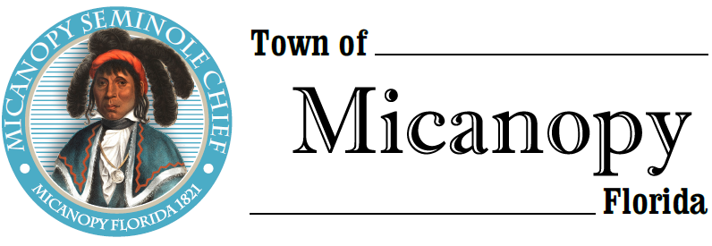
Town of Micanopy
Town Commission • Regularly Scheduled Meeting via Virtual Conferencing
Tuesday • August 11, 2020 • 7:00 PM
______________________________________________________________________
A G E N D A
1. Call to Order

2. Invocation & Pledge of Allegiance to Flag

3. Roll Call

4. Consent Agenda
A) Agenda Approval
B) Minutes of Regular Meeting of July 14, 2020,
C) Review & Acceptance of Financial Transactions & Reports

5. Citizen’s Forum – Public Comment (Use Zoom meeting below or email townhall@micanopytown.com in advance of meeting)

6. Citizen Board and Committee Reports
A) Planning & Historic Preservation Board
B) Tree Committee

7. Town Attorney Report

8. Town Administrator Report
A) Preliminary Annual Budget – Rollback Millage Rate 5.5260
1) Tentative Millage/Budget Public Hearing September 14, 2020 @ 6pm
2) Final Millage/Budget Public Hearing September 28, 2020 @ 6pm

9. New Business
A) 11-Month CD Maturing August 21st
B) Curb Inlet Damage by Micanopy Area Charter School Contractor
C) Organized Ballpark Sports Program

10. Unfinished Business
A) Demolition and Construction of Basketball Court at Firehouse Playground Starting Week of August 17th
B) Clean Up Day Scheduled Saturday, September 12th 8am-11:30am
C) Planning & Historic Preservation Board LED Lights Recommendation

11. Town Commissioner Reports
• Commissioner (Seat 2) Tim Parker • Commissioner (Seat 3) Ginny Mance
• Commissioner (Seat 4) Troy Blakely • Commissioner (Seat 5) Mike Roberts

12. Mayor Joe Aufmuth Report

13. Adjourn

Join Zoom Meeting Dial by your location
https://us02web.zoom.us/j/4849692951 +1 301 715 8592 US (Germantown)
+1 312 626 6799 US (Chicago)
Meeting ID: 484 969 2951 +1 929 205 6099 US (New York)
One tap mobile +1 253 215 8782 US (Tacoma)
+13017158592,,4849692951# US (Germantown) +1 346 248 7799 US (Houston)
+13126266799,,4849692951# US (Chicago) +1 669 900 6833 US (San Jose)
Find your local number: https://us02web.zoom.us/u/kdBFQf6M7Z

PLEASE NOTE: PURSUANT TO SECTION 286.015, FLORIDA STATUTES, IF A PERSON DECIDES TO APPEAL ANY DECISION MADE BY THE COMMISSION WITH RESPECT TO ANY MATTER CONSIDERED DURING THIS MEETING, HE OR SHE WILL NEED TO ENSURE THAT A VERBATIM RECORD OF THE PROCEEDINGS IS MADE, WHICH RECORD INCLUDES THE TESTIMONY AND EVIDENCE UPON WHICH THE APPEAL IS TO BE BASED. IN ACCORDANCE WITH THE AMERICAN WITH DISABILITIES ACT, A PERSON WITH DISABILITIES NEEDING ANY SPECIAL ACCOMODATIONS TO PARTICIPATE IN TOWN MEETINGS SHOULD CONTACT THE TOWN ADMINISTRATOR, 706 NE CHOLOKKA BLVD., MICANOPY, FLORIDA 32667-0137, TELEPHONE (352) 466-3121.

