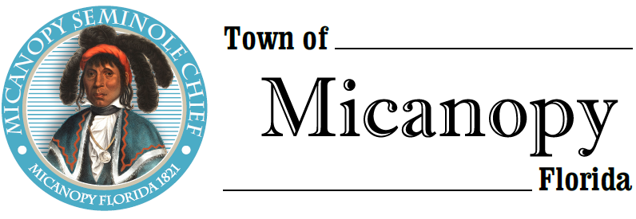

Town Commission • Regularly Scheduled Meeting
Tuesday • August 13, 2019 • 7:30 PM
___________________________________________________________________________________________________________
A G E N D A
- Call to Order

2. Invocation & Pledge of Allegiance to Flag

3. Roll Call

4. Consent Agenda
A) Agenda Approval
B) Minutes of Regular Meeting of July 9, 2019
C) Review & Acceptance of Financial Transactions & Reports

5. Guests
A) Carolyn Wallace, Alachua County Library District, Micanopy Branch

6. Citizen’s Forum (public comments limited to 5 minutes per speaker, please)

7. Citizen Board and Committee Reports
A) Planning & Historic Preservation Board
B) Tree Committee

8. Town Attorney Report
A) Status of Acquisition of CR234 Bypass Property & Entrance Triangle
B) Resolution 2019-12 Fee Schedule
C) Consultant’s Competitive Negotiation Act (CCNA) Engineer Ranking Sheets
D) Business Tax Receipts/Occupational License Fees

9. Town Administrator Report
A) Preliminary Annual Budget 2019-2020 – Rollback Rate 5.6542
1) Tentative Millage/Budget Public Hearing September 9, 2019 & Final Millage/Budget Public Hearing September 23, 2019
B) Water System Improvements – Automatic Flush Valves Installed

10. New Business
A) REV E-261 Pumper Repair Estimate

11. Unfinished Business
A) CDBG Grant Status
1) Resolution 2019-13 504 Handicapped Accessibility Plan
2) Workshop Attendance – Week of October 28th
B) Ballpark Improvement Project Status – RFP Roofing, RFP Playground Equipment, Concrete Picnic Tables Quote
C) Firehouse Playground Park – RFP Basketball Court
D) Firehouse Renovation Project

12. Town Commissioner Reports
• Commissioner (Seat 2) Tim Parker
• Commissioner (Seat 3) Ed Burnett
• Commissioner (Seat 4) Troy Blakely
• Commissioner (Seat 5) Mike Roberts

13. Mayor Joe Aufmuth Report

14. Adjourn
PLEASE NOTE: PURSUANT TO SECTION 286.015, FLORIDA STATUTES, IF A PERSON DECIDES TO APPEAL ANY DECISION MADE BY THE COMMISSION WITH RESPECT TO ANY MATTER CONSIDERED DURING THIS MEETING, HE OR SHE WILL NEED TO ENSURE THAT A VERBATIM RECORD OF THE PROCEEDINGS IS MADE, WHICH RECORD INCLUDES THE TESTIMONY AND EVIDENCE UPON WHICH THE APPEAL IS TO BE BASED. IN ACCORDANCE WITH THE AMERICAN WITH DISABILITIES ACT, A PERSON WITH DISABILITIES NEEDING ANY SPECIAL ACCOMODATIONS TO PARTICIPATE IN TOWN MEETINGS SHOULD CONTACT THE TOWN ADMINISTRATOR, 706 NE CHOLOKKA BLVD., MICANOPY, FLORIDA 32667-0137, TELEPHONE (352) 466-3121.

