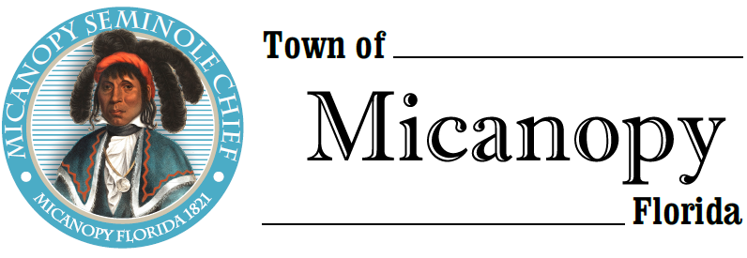
Town of Micanopy
Town Commission • Regularly Scheduled Meeting
Tuesday • December 10, 2019 • 7:00 PM
A G E N D A
__________________________________________________________________________________________

1. Call to Order

2. Invocation & Pledge of Allegiance to Flag

3. Roll Call

4. Consent Agenda
A) Agenda Approval
B) Minutes of Regular Meeting of November 12, 2019
C) Review & Acceptance of Financial Transactions & Reports

5. Guests
A) Trisha Roy, Alachua County Commission Candidate District 3
B) Carolyn Wallace, Alachua County Library District, Micanopy Branch

6. Citizen’s Forum (public comments limited to 5 minutes per speaker, please)

7. Citizen Board and Committee Reports
A) Planning & Historic Preservation Board
B) Tree Committee

8. Town Attorney Report
A) George F. Young Contract

9. Town Administrator Report

10. New Business
A) Proclamation of Appreciation for Les Singleton
B) Micanopy Historic Preservation Trust – Old Jail Renovation
C) Zero Turn Mower Purchase

11. Unfinished Business
A) Board Member Term Expirations and New Applicants:
1) David Massey, P&HPB 4) Paul Cohen, Tree Committee
2) Fro Warren, P&HPB 5) Gary C. Hunt, Tree Committee
3) Buddy Barnard, Code
B) Ballpark Improvement Project – Playground Surface
C) RFP – Basketball Court Renovation at Firehouse Playground
D) Micanopy Historic Cemetery – Town-owned Adjoining Parcels

12. Town Commissioner Reports
• Commissioner (Seat 2) Tim Parker • Commissioner (Seat 4) Troy Blakely
• Commissioner (Seat 3) Ed Burnett • Commissioner (Seat 5) Mike Roberts

13. Mayor (Seat 1) Joe Aufmuth Report

14. Adjourn
________________________________________________________________________________________________________
PLEASE NOTE: PURSUANT TO SECTION 286.015, FLORIDA STATUTES, IF A PERSON DECIDES TO APPEAL ANY DECISION MADE BY THE COMMISSION WITH RESPECT TO ANY MATTER CONSIDERED DURING THIS MEETING, HE OR SHE WILL NEED TO ENSURE THAT A VERBATIM RECORD OF THE PROCEEDINGS IS MADE, WHICH RECORD INCLUDES THE TESTIMONY AND EVIDENCE UPON WHICH THE APPEAL IS TO BE BASED. IN ACCORDANCE WITH THE AMERICAN WITH DISABILITIES ACT, A PERSON WITH DISABILITIES NEEDING ANY SPECIAL ACCOMODATIONS TO PARTICIPATE IN TOWN MEETINGS SHOULD CONTACT THE TOWN ADMINISTRATOR, 706 NE CHOLOKKA BLVD., MICANOPY, FLORIDA 32667-0137, TELEPHONE (352) 466-3121.

