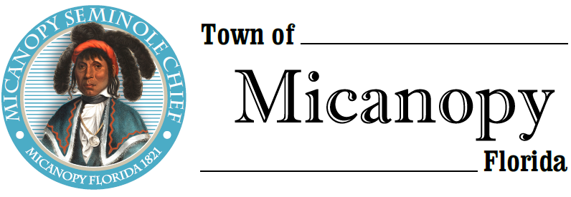
Town of Micanopy
Town Commission • Regularly Scheduled Meeting
Tuesday • February 9, 2021 • 7:00 PM
_________________________________________________________________________________
A G E N D A
THE TOWN OF MICANOPY WILL REQUIRE ALL ATTENDEES TO WEAR A FACE MASK. SOCIAL DISTANCING AND ALACHUA COUNTY HEALTH SAFETY GUIDELINES WILL BE FOLLOWED.

1. Call to Order

2. Invocation & Pledge of Allegiance to Flag

3. Roll Call

4. Consent Agenda
A) Agenda Approval
B) Minutes of Regular Meeting of January 12, 2021 and Charter Changes Workshop of January 19, 2021
C) Review & Acceptance of Financial Transactions & Reports

5. Guests
A) Richard Powell, Powell & Jones, CPA – 2020 Annual Audit Report

6. Citizen’s Forum – Public Comment (public comments limited to 5 minutes per speaker, please)

7. Citizen Board and Committee Reports
A) Planning & Historic Preservation Board
1) Street Light Recommendation
B) Tree Committee

8. Town Attorney Report
A) Proposed Charter Changes

9. Town Administrator Report
A) Clean-Up Day Saturday, April 24th

10. New Business
A) 3 Month CD Matures February 21, 2021
B) Additional Firehouse and Ballpark Playground Improvements
C) Gainesville Chamber of Commerce Regional Contact
D) Battle of Micanopy – Battlefield Site
E) Remzey Samarrai 1st Edition Octavio Micanopy Lithograph Gift
F) Town Administrator Position

11. Unfinished Business
A) Dollar General/CRS Micanopy

12. Town Commissioner Reports
• Commissioner (Seat 2) Tim Parker • Commissioner (Seat 3) Ginny Mance
• Commissioner (Seat 4) Troy Blakely • Commissioner (Seat 5) Mike Roberts

13. Mayor (Seat 1) Joe Aufmuth Report

14. Adjourn
PLEASE NOTE: PURSUANT TO SECTION 286.015, FLORIDA STATUTES, IF A PERSON DECIDES TO APPEAL ANY DECISION MADE BY THE COMMISSION WITH RESPECT TO ANY MATTER CONSIDERED DURING THIS MEETING, HE OR SHE WILL NEED TO ENSURE THAT A VERBATIM RECORD OF THE PROCEEDINGS IS MADE, WHICH RECORD INCLUDES THE TESTIMONY AND EVIDENCE UPON WHICH THE APPEAL IS TO BE BASED. IN ACCORDANCE WITH THE AMERICAN WITH DISABILITIES ACT, A PERSON WITH DISABILITIES NEEDING ANY SPECIAL ACCOMODATIONS TO PARTICIPATE IN TOWN MEETINGS SHOULD CONTACT THE TOWN ADMINISTRATOR, 706 NE CHOLOKKA BLVD., MICANOPY, FLORIDA 32667-0137, TELEPHONE (352) 466-3121.

