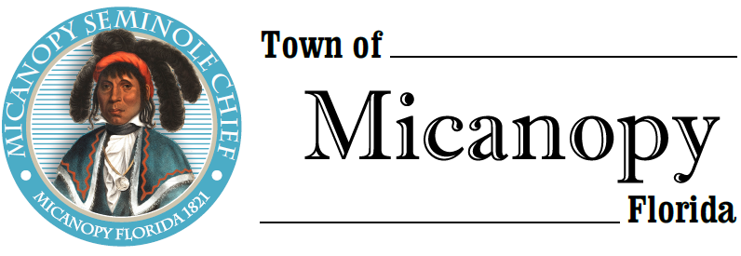
Town of Micanopy
Town Commission • Regularly Scheduled Meeting via Virtual Conferencing
Tuesday • July 14, 2020 • 7:00 PM
______________________________________________________________________
A G E N D A
1. Call to Order

2. Invocation & Pledge of Allegiance to Flag

3. Roll Call

4. Consent Agenda
A) Agenda Approval
B) Minutes of Regular & Canvassing Board Meetings of June 9, 2020, Social Media Workshop of June 16, 2020, &
Large Retail Store Special Meeting of June 18, 2020
C) Review & Acceptance of Financial Transactions & Reports

5. Guests
A) Richard Powell, Powell & Jones, CPA – Annual Audit Report

6. Citizen’s Forum – Public Comment (Use Zoom meeting below or email townhall@micanopytown.com in advance of meeting)

7. Town Attorney Report
A) George F. Young’s Micanopy Fire Station Proposal

8. Town Administrator Report
A) Preliminary Annual Budget
1) Vote on Rollback Rate 5.5260
2) Tentative Millage/Budget Public Hearing September 14, 2020
3) Final Millage/Budget Public Hearing September 28, 2020

9. New Business

10. Unfinished Business
A) Status Demolition and Construction of Basketball Court at Firehouse Playground
B) Town Meeting Notice Policy Update

11. Town Commissioner Reports
• Commissioner (Seat 2) Tim Parker
• Commissioner (Seat 3) Ginny Mance
• Commissioner (Seat 4) Troy Blakely
• Commissioner (Seat 5) Mike Roberts

12. Mayor Joe Aufmuth Report

13. Adjourn
Join Zoom Meeting Dial by your location
https://us02web.zoom.us/j/4849692951 +1 301 715 8592 US (Germantown)
+1 312 626 6799 US (Chicago)
Meeting ID: 484 969 2951 +1 929 205 6099 US (New York)
One tap mobile +1 253 215 8782 US (Tacoma)
+13017158592,,4849692951# US (Germantown) +1 346 248 7799 US (Houston)
+13126266799,,4849692951# US (Chicago) +1 669 900 6833 US (San Jose)
Meeting ID: 484 969 2951
Find your local number: https://us02web.zoom.us/u/kdBFQf6M7Z
PLEASE NOTE: PURSUANT TO SECTION 286.015, FLORIDA STATUTES, IF A PERSON DECIDES TO APPEAL ANY DECISION MADE BY THE COMMISSION WITH RESPECT TO ANY MATTER CONSIDERED DURING THIS MEETING, HE OR SHE WILL NEED TO ENSURE THAT A VERBATIM RECORD OF THE PROCEEDINGS IS MADE, WHICH RECORD INCLUDES THE TESTIMONY AND EVIDENCE UPON WHICH THE APPEAL IS TO BE BASED. IN ACCORDANCE WITH THE AMERICAN WITH DISABILITIES ACT, A PERSON WITH DISABILITIES NEEDING ANY SPECIAL ACCOMODATIONS TO PARTICIPATE IN TOWN MEETINGS SHOULD CONTACT THE TOWN ADMINISTRATOR, 706 NE CHOLOKKA BLVD., MICANOPY, FLORIDA 32667-0137, TELEPHONE (352) 466-3121.

