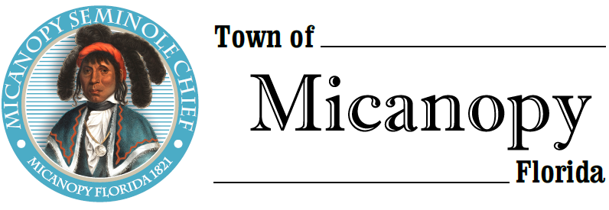
Town of Micanopy
Town Commission • Regularly Scheduled Meeting
Tuesday • June 8, 2021 • 7:00 PM
_________________________________________________________________________________
A G E N D A

1. Call to Order

2. Invocation & Pledge of Allegiance to Flag

3. Roll Call

4. Consent Agenda
A) Agenda Approval
B) Minutes of Regular Meeting of May 11, 2021
C) Review & Acceptance of Financial Transactions & Reports

5. Guests

6. Citizen’s Forum – Public Comment (public comments limited to 2 minutes per speaker, please)

7. Citizen Board and Committee Reports
A) Planning & Historic Preservation Board
B) Tree Committee

8. Town Attorney Report
A) Public Hearing: First Reading Ordinance No. 2021-02 Charter Changes
B) Public Hearing: First Reading Ordinance No. 2021-03 Duke Energy Rights of Way Utilization Franchise

9. Town Administrator Report

10. New Business
A) Well Project Contract Acceptance and Status Update
B) CD Matures June 21, 2021 and Investments
C) Micanopy Native American Heritage Preserve (MNAHP) Repairs
D) Town Air Conditioner Replacement/Repair Estimates
E) Suggestion to name Ballpark Concession Stand honoring Shirley Carrier
F) Karen Carpenter Request for Concrete Posts in Right-of-Way
G) Firehouse Interior Maintenance

11. Unfinished Business
A) Leslie Straub, Florida Wildlife Care Letter of Support

12. Town Commissioner Reports
• Commissioner (Seat 2) Tim Parker • Commissioner (Seat 3) Ginny Mance
• Commissioner (Seat 4) Troy Blakely • Commissioner (Seat 5) Mike Roberts

13. Mayor (Seat 1) Joe Aufmuth Report

14. Adjourn

PLEASE NOTE: PURSUANT TO SECTION 286.015, FLORIDA STATUTES, IF A PERSON DECIDES TO APPEAL ANY DECISION MADE BY THE COMMISSION WITH RESPECT TO ANY MATTER CONSIDERED DURING THIS MEETING, HE OR SHE WILL NEED TO ENSURE THAT A VERBATIM RECORD OF THE PROCEEDINGS IS MADE, WHICH RECORD INCLUDES THE TESTIMONY AND EVIDENCE UPON WHICH THE APPEAL IS TO BE BASED. IN ACCORDANCE WITH THE AMERICAN WITH DISABILITIES ACT, A PERSON WITH DISABILITIES NEEDING ANY SPECIAL ACCOMODATIONS TO PARTICIPATE IN TOWN MEETINGS SHOULD CONTACT THE TOWN ADMINISTRATOR, 706 NE CHOLOKKA BLVD., MICANOPY, FLORIDA 32667-0137, TELEPHONE (352) 466-3121.

