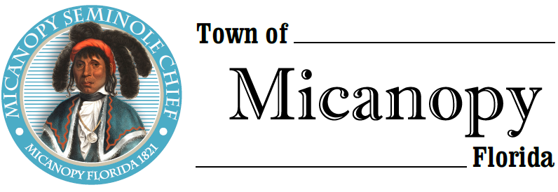
Town of Micanopy
Town Commission • Regularly Scheduled Meeting
Tuesday • March 9, 2021 • 7:00 PM
____________________________________________________________________________________________________________________________________________________________________________
AMENDED A G E N D A
THE TOWN OF MICANOPY WILL REQUIRE ALL ATTENDEES TO WEAR A FACE MASK. SOCIAL DISTANCING AND ALACHUA COUNTY HEALTH SAFETY GUIDELINES WILL BE FOLLOWED.
1. Call to Order

2. Invocation & Pledge of Allegiance to Flag

3. Roll Call

4. Consent Agenda
A) Agenda Approval
B) Minutes of Regular Meeting of February 9, 2021
C) Review & Acceptance of Financial Transactions & Reports

5. Swearing in of Commissioner Mance & Annual Organizational Meeting

6. Guests
A) Lena McNeer, Alachua County Library District

7. Citizen’s Forum – Public Comment (public comments limited to 5 minutes per speaker, please)

8. Citizen Board and Committee Reports
A) Planning & Historic Preservation Board
B) Tree Committee

9. Town Attorney Report
A) Proposed Charter Changes
B) Dollar General Stakeholder Engagement

10. Town Administrator Report

11. New Business
A) Special Event Permits, Facility Use Charges, & Penalties
B) Request from BoCC for a Joint Meeting (May 6th or May 13th)
C) Ordinance 2021-01 Vacate Right-of-Way
D) MACS School Expansion – Preschool
E) Micanopy 200th Anniversary Celebration

12. Unfinished Business
A) Micanopy Athletic Association Property Use Agreement
B) Great American Cleanup – Saturday, April 24th
C) Firehouse Roof Estimates
D) Town Administrator Position

13. Town Commissioner Reports
• Commissioner (Seat 2) Tim Parker • Commissioner (Seat 3) Ginny Mance
• Commissioner (Seat 4) Troy Blakely • Commissioner (Seat 5) Mike Roberts

14. Mayor (Seat 1) Joe Aufmuth Report

15. Adjourn
PLEASE NOTE: PURSUANT TO SECTION 286.015, FLORIDA STATUTES, IF A PERSON DECIDES TO APPEAL ANY DECISION MADE BY THE COMMISSION WITH RESPECT TO ANY MATTER CONSIDERED DURING THIS MEETING, HE OR SHE WILL NEED TO ENSURE THAT A VERBATIM RECORD OF THE PROCEEDINGS IS MADE, WHICH RECORD INCLUDES THE TESTIMONY AND EVIDENCE UPON WHICH THE APPEAL IS TO BE BASED. IN ACCORDANCE WITH THE AMERICAN WITH DISABILITIES ACT, A PERSON WITH DISABILITIES NEEDING ANY SPECIAL ACCOMODATIONS TO PARTICIPATE IN TOWN MEETINGS SHOULD CONTACT THE TOWN ADMINISTRATOR, 706 NE CHOLOKKA BLVD., MICANOPY, FLORIDA 32667-0137, TELEPHONE (352) 466-3121.

