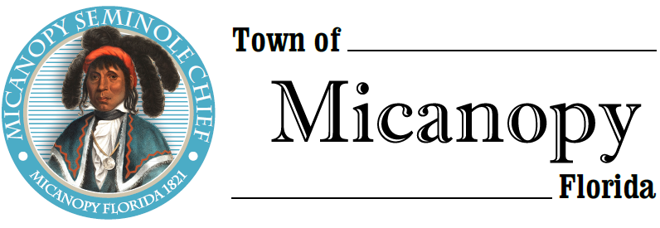
Town of Micanopy
Town Commission • Regularly Scheduled Meeting
Tuesday • March 10, 2020 • 7:30 PM
Upon Adjournment of Canvassing Board
A G E N D A
________________________________________________________________________

1. Call to Order

2. Invocation & Pledge of Allegiance to Flag

3. Roll Call

4. Consent Agenda
A) Agenda Approval
B) Minutes of Regular Meeting of February 11, 2020 & Engineering Workshop of February 18, 2020
C) Review & Acceptance of Financial Transactions & Reports

5. 2020 Town Commission Election – Swearing in of Commissioner
A) Organizational Meeting: Nomination & Vote for Mayor & Mayor Pro Tem

6. Guests
A) Carolyn Wallace, Alachua County Library District, Micanopy Branch

7. Citizen’s Forum (public comments limited to 5 minutes per speaker, please)

8. Citizen Board and Committee Reports
A) Planning & Historic Preservation Board
B) Tree Committee

9. Town Attorney Report

10. Town Administrator Report

11. New Business
A) Proclamation: March is Census Awareness Month
B) Kimley-Horn Engineering Agreement Proposal

12. Unfinished Business
A) Great American Cleanup – Saturday, April 4

13. Town Commissioner Reports
• Commissioner (Seat 2) Tim Parker
• Commissioner (Seat 3) Ed Burnett
• Commissioner (Seat 4) Troy Blakely
• Commissioner (Seat 5) Mike Roberts

14. Mayor (Seat 1) Joe Aufmuth Report

15. Adjourn
_______________________________________________________________________________________________________
PLEASE NOTE: PURSUANT TO SECTION 286.015, FLORIDA STATUTES, IF A PERSON DECIDES TO APPEAL ANY DECISION MADE BY THE COMMISSION WITH RESPECT TO ANY MATTER CONSIDERED DURING THIS MEETING, HE OR SHE WILL NEED TO ENSURE THAT A VERBATIM RECORD OF THE PROCEEDINGS IS MADE, WHICH RECORD INCLUDES THE TESTIMONY AND EVIDENCE UPON WHICH THE APPEAL IS TO BE BASED. IN ACCORDANCE WITH THE AMERICAN WITH DISABILITIES ACT, A PERSON WITH DISABILITIES NEEDING ANY SPECIAL ACCOMODATIONS TO PARTICIPATE IN TOWN MEETINGS SHOULD CONTACT THE TOWN ADMINISTRATOR, 706 NE CHOLOKKA BLVD., MICANOPY, FLORIDA 32667-0137, TELEPHONE (352) 466-3121.

