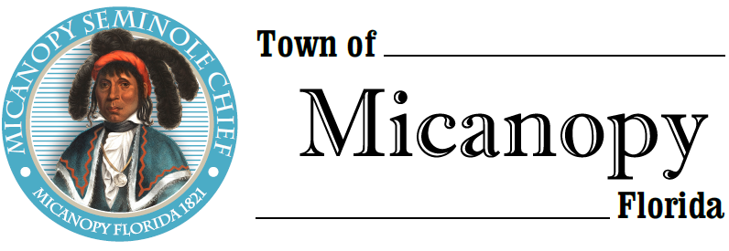
Town of Micanopy
Town Commission • Regularly Scheduled Meeting
Tuesday • May 14, 2019 • 7:30 PM

A G E N D A

- Call to Order

2. Invocation & Pledge of Allegiance to Flag

3. Roll Call

4. Consent Agenda
A) Agenda Approval
B) Minutes of Regular Meeting of April 9, 2019 and Special Meeting of April 23, 2019
C) Review & Acceptance of Financial Transactions & Reports

5. Guests
A) Paul Stresing Associates, Inc. Architect – Fire Department
B) Carolyn Wallace, Alachua County Library District, Micanopy Branch

6. Citizen’s Forum (public comments limited to 5 minutes per speaker, please)

7. Citizen Board and Committee Reports
A) Planning & Historic Preservation Board
B) Tree Committee

8. Town Attorney Report
A) Ordinance 2019-01 Tree Ordinance – Final Reading
B) Ordinance 2019-02 Flood Ordinance – Final Reading
C) Fred Fox Enterprise – FRDAP Administrative Contract
D) Proposed Alachua County/Micanopy Fire Suppression & First Response Interlocal Agreement (ILA)
E) Public Hearing – Appeal of P&HPB Alcoholic Beverage Establishment Decision Herlong Mansion

9. Town Administrator Report
A) Great American Cleanup Day Stats
B) Preliminary Annual Budget 2019-2020
C) Budgeted Computer Hardware/Software (Windows 7) Replacement

10. New Business
A) Hurricane Preparedness
1) Proclamation Hurricane Preparedness Month
2) Micanopy Hurricane Preparedness Brochure: Be Safe. Be Ready. Be Prepared!

11. Unfinished Business
A) ADA Compliant Website Status
B) CDBG Grant Application Status

12. Town Commissioner Reports
• Commissioner (Seat 2) Tim Parker
• Commissioner (Seat 3) Ed Burnett
• Commissioner (Seat 4) Troy Blakely
• Commissioner (Seat 5) Mike Roberts

13. Mayor Joe Aufmuth Report

14. Adjourn
PLEASE NOTE: PURSUANT TO SECTION 286.015, FLORIDA STATUTES, IF A PERSON DECIDES TO APPEAL ANY DECISION MADE BY THE COMMISSION WITH RESPECT TO ANY MATTER CONSIDERED DURING THIS MEETING, HE OR SHE WILL NEED TO ENSURE THAT A VERBATIM RECORD OF THE PROCEEDINGS IS MADE, WHICH RECORD INCLUDES THE TESTIMONY AND EVIDENCE UPON WHICH THE APPEAL IS TO BE BASED. IN ACCORDANCE WITH THE AMERICAN WITH DISABILITIES ACT, A PERSON WITH DISABILITIES NEEDING ANY SPECIAL ACCOMODATIONS TO PARTICIPATE IN TOWN MEETINGS SHOULD CONTACT THE TOWN ADMINISTRATOR, 706 NE CHOLOKKA BLVD., MICANOPY, FLORIDA 32667-0137, TELEPHONE (352) 466-3121.

