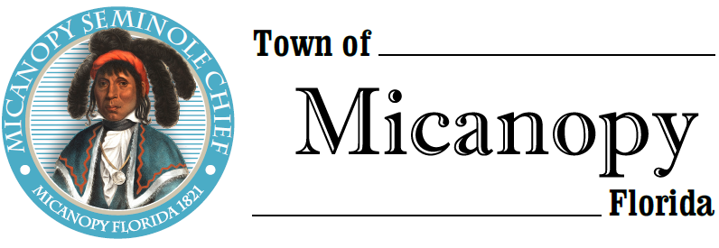
Town of Micanopy
Town Commission • Regularly Scheduled Meeting
Tuesday • November 10, 2020 • 7:00 PM
_________________________________________________________________________________
A G E N D A
THE TOWN OF MICANOPY WILL REQUIRE ALL ATTENDEES TO WEAR A FACE MASK. SOCIAL DISTANCING AND ALACHUA COUNTY HEALTH SAFETY GUIDELINES WILL BE FOLLOWED.
1. Call to Order

2. Invocation & Pledge of Allegiance to Flag

3. Roll Call

4. Consent Agenda
A) Agenda Approval
B) Minutes of Regular Meeting of October 13, 2020
C) Review & Acceptance of Financial Transactions & Reports

5. Guests

6. Citizen’s Forum – Public Comment Limited to 5 Minutes per Speaker

7. Citizen Board and Committee Reports
A) Planning & Historic Preservation Board
B) Tree Committee

8. Town Attorney Report
A) Curb Inlet Damage by Micanopy Area Charter School Contractor

9. Town Administrator Report

10. New Business
A) 3 Month CD Matures December 21, 2020
B) Request for Speed Bump on North Division Street

11. Unfinished Business
A) Citizen Board Term Expirations: Gary Hunt, Tree Committee & Stanley Strobles, Code Board
B) Proposed Charter Changes
C) LDC Section 6.17.04(A) Maximum Building Footprint Discussion
D) Infrastructure Improvements (Water System, Sewer System, Streets)
E) Fire Department Expected Costs

12. Town Commissioner Reports
• Commissioner (Seat 2) Tim Parker • Commissioner (Seat 3) Ginny Mance
• Commissioner (Seat 4) Troy Blakely • Commissioner (Seat 5) Mike Roberts

13. Mayor (Seat 1) Joe Aufmuth Report

14. Adjourn

PLEASE NOTE: PURSUANT TO SECTION 286.015, FLORIDA STATUTES, IF A PERSON DECIDES TO APPEAL ANY DECISION MADE BY THE COMMISSION WITH RESPECT TO ANY MATTER CONSIDERED DURING THIS MEETING, HE OR SHE WILL NEED TO ENSURE THAT A VERBATIM RECORD OF THE PROCEEDINGS IS MADE, WHICH RECORD INCLUDES THE TESTIMONY AND EVIDENCE UPON WHICH THE APPEAL IS TO BE BASED. IN ACCORDANCE WITH THE AMERICAN WITH DISABILITIES ACT, A PERSON WITH DISABILITIES NEEDING ANY SPECIAL ACCOMODATIONS TO PARTICIPATE IN TOWN MEETINGS SHOULD CONTACT THE TOWN ADMINISTRATOR, 706 NE CHOLOKKA BLVD., MICANOPY, FLORIDA 32667-0137, TELEPHONE (352) 466-3121.

