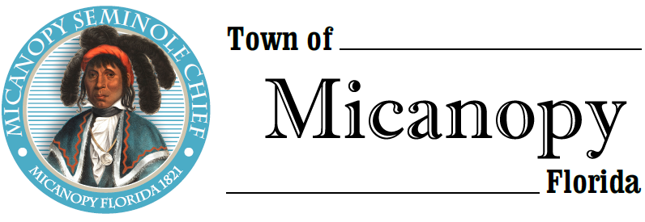
Town of Micanopy
Town Commission • Regularly Scheduled Meeting via Virtual Conferencing
Tuesday • October 13, 2020 • 7:00 PM
_________________________________________________________________________________

A G E N D A

1. Call to Order

2. Invocation & Pledge of Allegiance to Flag

3. Roll Call

4. Consent Agenda
A) Agenda Approval
B) Minutes of Regular Meeting of September 8, 2020, Dollar General Opposition Letter Special Meeting of September 14, 2020, and Tentative & Final Millage/Budget Public Hearings of September 14, 2020 & September 28, 2020
C) Review & Acceptance of Financial Transactions & Reports

5. Guests
A) Joy Glanzer, Candidate for Alachua County Commission

6. Citizen’s Forum – Public Comment (Use Zoom meeting below or email townhall@micanopytown.com in advance of meeting)

7. Citizen Board and Committee Reports
A) Planning & Historic Preservation Board (P&HPB)
B) Tree Committee

8. Town Attorney Report
A) City of Alachua Charter Referendum Lawsuit

9. Town Administrator Report

10. New Business
A) Charter Change – Residency Requirement Time Frame
B) Resolution 2020-11 Procurement
C) Citizen Board Term Expirations: Seat #5 P&HPB; Gary Hunt, Tree Committee; Stanley Strobles, Code Board
1) Steve Elder Application for P&HPB

11. Unfinished Business

12. Town Commissioner Reports
• Commissioner (Seat 2) Tim Parker • Commissioner (Seat 3) Ginny Mance
• Commissioner (Seat 4) Troy Blakely • Commissioner (Seat 5) Mike Roberts

13. Mayor (Seat 1) Joe Aufmuth Report

14. Adjourn Join Zoom Meeting Dial by your location
https://us02web.zoom.us/j/4849692951 +1 301 715 8592 US (Germantown)
+1 312 626 6799 US (Chicago)
Meeting ID: 484 969 2951 +1 929 205 6099 US (New York)
One tap mobile +1 253 215 8782 US (Tacoma)
+13017158592,,4849692951# US (Germantown) +1 346 248 7799 US (Houston)
+13126266799,,4849692951# US (Chicago) +1 669 900 6833 US (San Jose)
Find your local number: https://us02web.zoom.us/u/kdBFQf6M7Z

PLEASE NOTE: PURSUANT TO SECTION 286.015, FLORIDA STATUTES, IF A PERSON DECIDES TO APPEAL ANY DECISION MADE BY THE COMMISSION WITH RESPECT TO ANY MATTER CONSIDERED DURING THIS MEETING, HE OR SHE WILL NEED TO ENSURE THAT A VERBATIM RECORD OF THE PROCEEDINGS IS MADE, WHICH RECORD INCLUDES THE TESTIMONY AND EVIDENCE UPON WHICH THE APPEAL IS TO BE BASED. IN ACCORDANCE WITH THE AMERICAN WITH DISABILITIES ACT, A PERSON WITH DISABILITIES NEEDING ANY SPECIAL ACCOMODATIONS TO PARTICIPATE IN TOWN MEETINGS SHOULD CONTACT THE TOWN ADMINISTRATOR, 706 NE CHOLOKKA BLVD., MICANOPY, FLORIDA 32667-0137, TELEPHONE (352) 466-3121.

