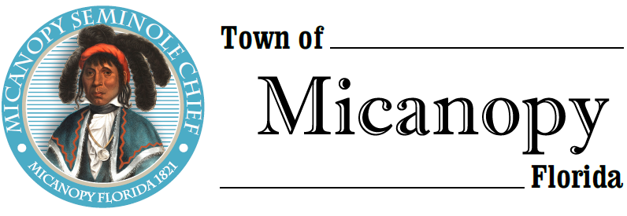
Town of Micanopy
Town Commission • Regularly Scheduled Meeting
Tuesday • October 8, 2019 • 7:30 PM
_____________________________________________________________________________________________

A G E N D A

1. Call to Order

2. Invocation & Pledge of Allegiance to Flag

3. Roll Call

4. Consent Agenda
A) Agenda Approval
B) Minutes of Regular Meeting of September 10, 2019, Special Meeting of September 23, 2019, and
Millage/Budget Hearings of September 9, 2019 and September 23, 2019
C) Review & Acceptance of Financial Transactions & Reports

5. Guests
A) Jerry Dabkowski, George F. Young, Inc.
B) Carolyn Wallace, Alachua County Library District, Micanopy Branch

6. Citizen’s Forum (public comments limited to 5 minutes per speaker, please)

7. Public Hearing
A) Application No. CPA 19-01 (Evaluation Based Amendments to the Comprehensive Plan): Consideration of an application by the Town Commission to amend the text and Future Land Use Plan Map of the Comprehensive Plan, based upon an evaluation completed by the Town, to reflect changes in state requirements pursuant to section 163.3191, Florida Statutes, as amended.
1) Public Comments in Favor of CPA 19-01
2) Public Comments Opposed to CPA 19-01
3) Close Public Comment for CPA 19-01

8. Citizen Board and Committee Reports
A) Planning & Historic Preservation Board
B) Tree Committee

9. Town Attorney Report
A) Ordinance No. 2019-03 Comprehensive Plan Amendment (CPA 19-01) Second Reading of Comprehensive Plan Evaluation Based Amendments
B) First Reading - Ordinance No. 2019-04 Occupational License Tax (Business Tax Receipts)
C) Resolution 2019-18 Fee Schedule

10. Town Administrator Report

11. New Business
A) Nomanbhoy Family, Ltd. Partnership – Request for Forgiveness of Demolition Lien Parcel #16520- 031-001 totaling $3,850.30

12. Unfinished Business
A) Duke Energy Battery Storage Plant
B) CDBG Grant
1) Acceptance of DEO Award Agreement
2) As part of the Town’s award agreement with DEO for the Small Cities CDBG, the Town is required to follow CDBG procurement procedures in solicitations for grant administrators and engineers. On August 27, 2019, the Town advertised in the Gainesville Sun for grant administrators and engineers. The Town received one proposal for grant administration and one proposal for engineering. As part of the procurement process, the Commission needs to formally award the grant administration and engineering upon DEO approval of the Town’s procurement process for both.
a) Administration Award: Fred Fox Enterprises, Inc.
b) Engineering Award: Kimley-Horn
C) Ballpark Improvement Project
1) Roofs
2) Playground Equipment
3) Playground Surface
D) RFP – Basketball Court Renovation at Firehouse Playground

13. Town Commissioner Reports
• Commissioner (Seat 2) Tim Parker
• Commissioner (Seat 3) Ed Burnett
• Commissioner (Seat 4) Troy Blakely
• Commissioner (Seat 5) Mike Roberts

14. Mayor Joe Aufmuth Report

15. Adjourn

________________________________________________________________________________________________________

PLEASE NOTE: PURSUANT TO SECTION 286.015, FLORIDA STATUTES, IF A PERSON DECIDES TO APPEAL ANY DECISION MADE BY THE COMMISSION WITH RESPECT TO ANY MATTER CONSIDERED DURING THIS MEETING, HE OR SHE WILL NEED TO ENSURE THAT A VERBATIM RECORD OF THE PROCEEDINGS IS MADE, WHICH RECORD INCLUDES THE TESTIMONY AND EVIDENCE UPON WHICH THE APPEAL IS TO BE BASED. IN ACCORDANCE WITH THE AMERICAN WITH DISABILITIES ACT, A PERSON WITH DISABILITIES NEEDING ANY SPECIAL ACCOMODATIONS TO PARTICIPATE IN TOWN MEETINGS SHOULD CONTACT THE TOWN ADMINISTRATOR, 706 NE CHOLOKKA BLVD., MICANOPY, FLORIDA 32667-0137, TELEPHONE (352) 466-3121.

