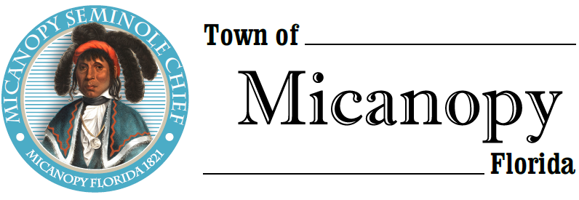
Town of Micanopy
Town Commission • Regularly Scheduled Meeting via Virtual Conferencing
Tuesday • September 8, 2020 • 7:00 PM
_________________________________________________________________________________
A G E N D A
1. Call to Order

2. Invocation & Pledge of Allegiance to Flag

3. Roll Call

4. Consent Agenda
A) Agenda Approval
B) Minutes of Regular Meeting of August 11, 2020
C) Review & Acceptance of Financial Transactions & Reports

5. Guests
A) Raemi Eagle-Glenn, Candidate for Alachua County Commission

6. Citizen’s Forum – Public Comment (Use Zoom meeting below or email townhall@micanopytown.com in advance of meeting)

7. Citizen Board and Committee Reports
A) Planning & Historic Preservation Board
B) Tree Committee

8. Town Attorney Report
A) Release of Lien 203 NW Eestaulustee Avenue – Parcel #16520-031-001
B) Curb Inlet Damage by Micanopy Area Charter School Contractor

9. Town Administrator Report
A) Preliminary Annual Budget – Rollback Millage Rate 5.5260
1) Millage/Budget Public Hearings: Tentative September 14th @ 6pm & Final September 28th @ 6pm
B) Clean Up Day Scheduled Saturday, September 12th 8am-11:30am

10. New Business
A) 15-Month CD Maturing September 21st
B) SCADA System Quotes
C) E-64 Radiator Replacement
D) Resolution 2020-09 Opposing Alachua County Growth Management Charter Amendment
E) North Central Florida Regional Planning Council Annual Agreement Renewal
F) Citizen Committees - Planning & Historic Preservation Board Qualification List

11. Unfinished Business

12. Town Commissioner Reports
• Commissioner (Seat 2) Tim Parker • Commissioner (Seat 3) Ginny Mance
• Commissioner (Seat 4) Troy Blakely • Commissioner (Seat 5) Mike Roberts

13. Mayor (Seat 1) Joe Aufmuth Report

14. Adjourn Join Zoom Meeting Dial by your location
https://us02web.zoom.us/j/4849692951 +1 301 715 8592 US (Germantown)
+1 312 626 6799 US (Chicago)
Meeting ID: 484 969 2951 +1 929 205 6099 US (New York)
One tap mobile +1 253 215 8782 US (Tacoma)
+13017158592,,4849692951# US (Germantown) +1 346 248 7799 US (Houston)
+13126266799,,4849692951# US (Chicago) +1 669 900 6833 US (San Jose)
Find your local number: https://us02web.zoom.us/u/kdBFQf6M7Z
PLEASE NOTE: PURSUANT TO SECTION 286.015, FLORIDA STATUTES, IF A PERSON DECIDES TO APPEAL ANY DECISION MADE BY THE COMMISSION WITH RESPECT TO ANY MATTER CONSIDERED DURING THIS MEETING, HE OR SHE WILL NEED TO ENSURE THAT A VERBATIM RECORD OF THE PROCEEDINGS IS MADE, WHICH RECORD INCLUDES THE TESTIMONY AND EVIDENCE UPON WHICH THE APPEAL IS TO BE BASED. IN ACCORDANCE WITH THE AMERICAN WITH DISABILITIES ACT, A PERSON WITH DISABILITIES NEEDING ANY SPECIAL ACCOMODATIONS TO PARTICIPATE IN TOWN MEETINGS SHOULD CONTACT THE TOWN ADMINISTRATOR, 706 NE CHOLOKKA BLVD., MICANOPY, FLORIDA 32667-0137, TELEPHONE (352) 466-3121.

