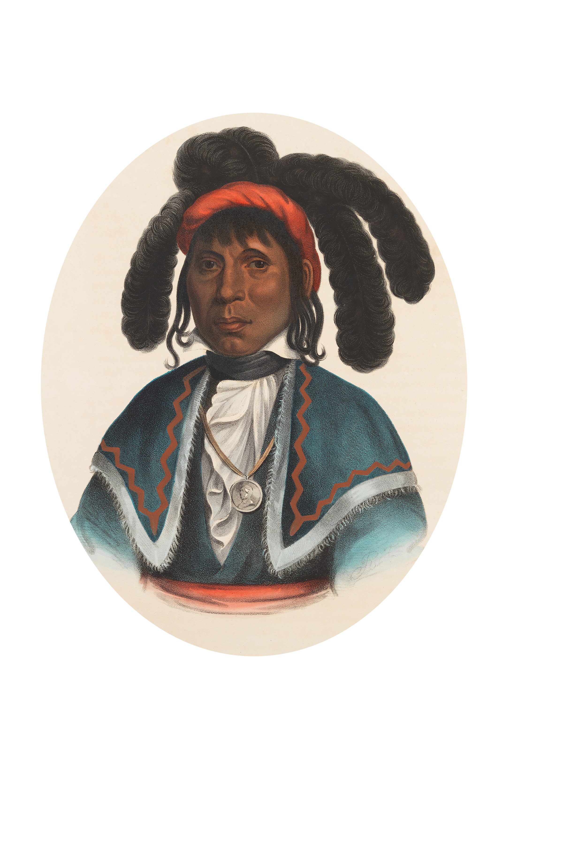

Town of Micanopy
• Special Meeting •
Community Development Block Grant (CDBG)
MICANOPY, SEMINOLE CHIEF
Project Selection
Thursday • March 28, 2019 • 5:00 PM

A G E N D A
1. Call to Order

2. Invocation & Pledge of Allegiance to Flag

3. Roll Call

4. Agenda Approval

5. Community Development Block Grant (CDBG) Neighborhood Revitalization Project – Project Selection
A) Drill New Well
B) Replace Water Lines
C) Upgrade Water Treatment Plant
D) Drive-By Meters
E) Other Projects

6. Adjourn

PLEASE NOTE: PURSUANT TO SECTION 286.015, FLORIDA STATUTES, IF A PERSON DECIDES TO APPEAL ANY DECISION MADE BY THE COMMISSION WITH RESPECT TO ANY MATTER CONSIDERED DURING THIS MEETING, HE OR SHE WILL NEED TO ENSURE THAT A VERBATIM RECORD OF THE PROCEEDINGS IS MADE, WHICH RECORD INCLUDES THE TESTIMONY AND EVIDENCE UPON WHICH THE APPEAL IS TO BE BASED. IN ACCORDANCE WITH THE AMERICAN WITH DISABILITIES ACT, A PERSON WITH DISABILITIES NEEDING ANY SPECIAL ACCOMODATIONS TO PARTICIPATE IN TOWN MEETINGS SHOULD CONTACT THE TOWN ADMINISTRATOR, 706 NE CHOLOKKA BLVD., MICANOPY, FLORIDA 32667-0137, TELEPHONE (352) 466-3121.

