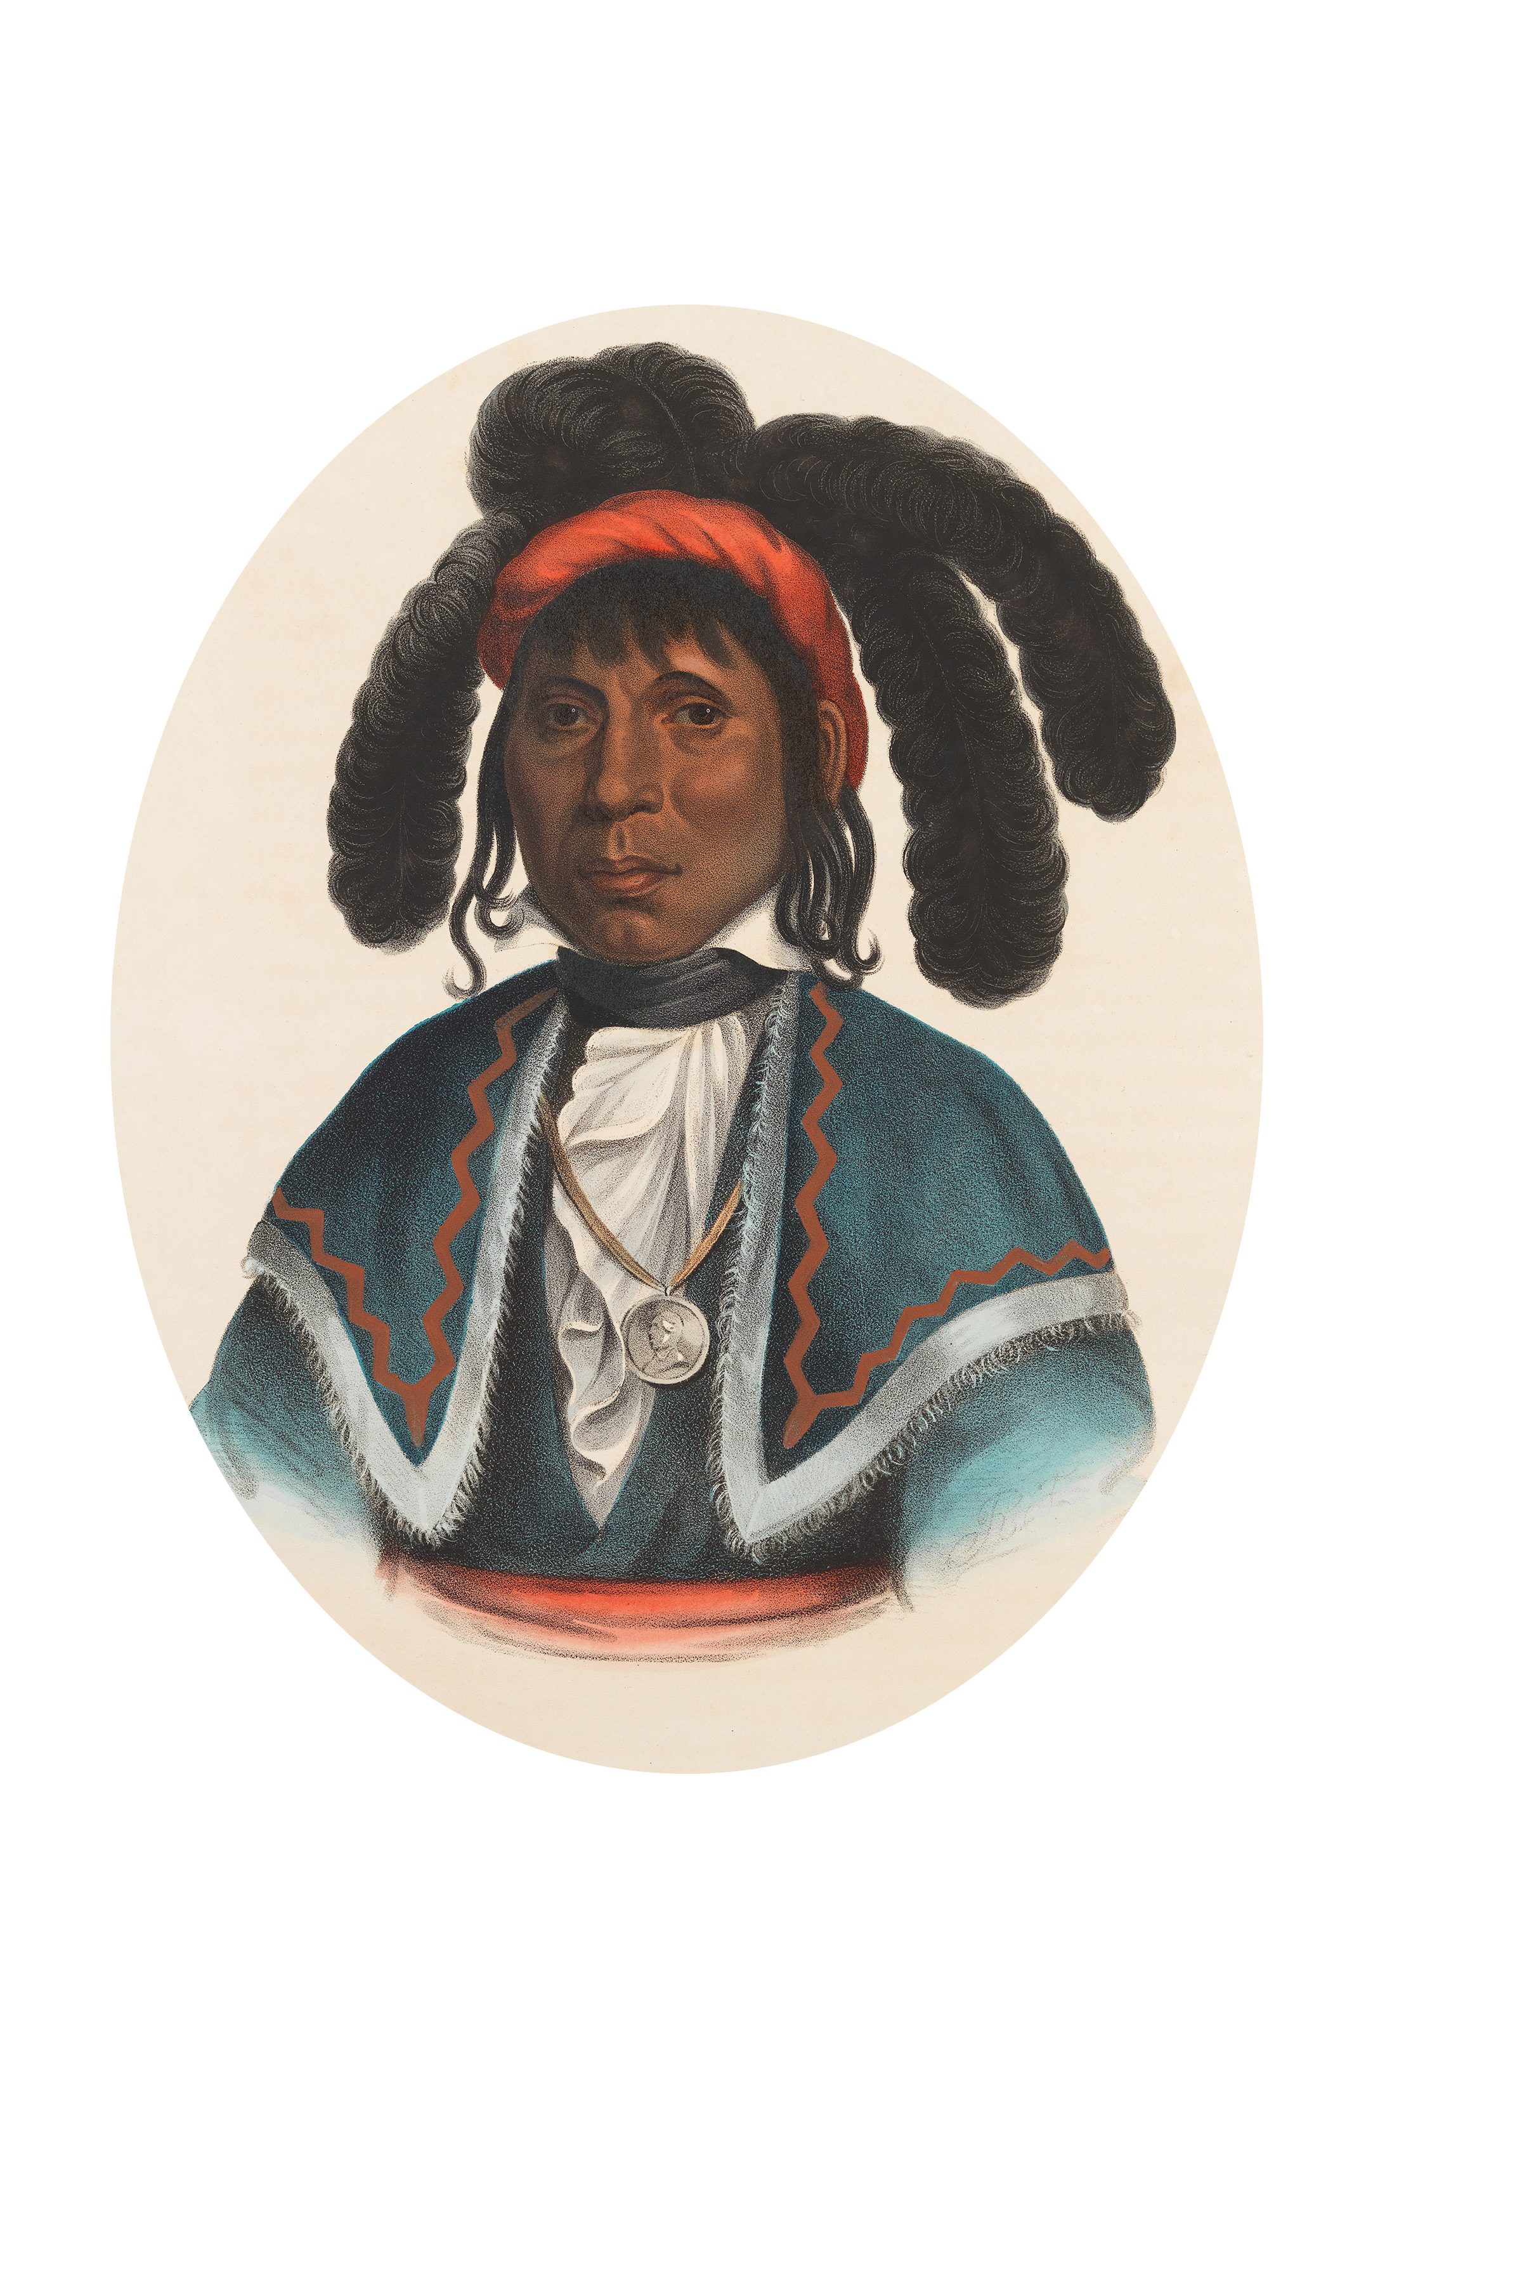

Town of Micanopy
• Special Meeting •
Special Election
MICANOPY, SEMINOLE CHIEF
Tuesday • February 26, 2019 • 6:00 PM

A G E N D A
1. Call to Order

2. Invocation & Pledge of Allegiance to Flag

3. Roll Call

4. Agenda Approval

5. Resolution 2019-02 Special Election
A) Special Election Seat #3
B) Qualifying Period Monday, March 4, 2019-Thursday, March 7, 2019
C) Election Date Tuesday, April 9, 2019
D) Runoff Date Tuesday, April 16, 2019

6. Adjourn

PLEASE NOTE: PURSUANT TO SECTION 286.015, FLORIDA STATUTES, IF A PERSON DECIDES TO APPEAL ANY DECISION MADE BY THE COMMISSION WITH RESPECT TO ANY MATTER CONSIDERED DURING THIS MEETING, HE OR SHE WILL NEED TO ENSURE THAT A VERBATIM RECORD OF THE PROCEEDINGS IS MADE, WHICH RECORD INCLUDES THE TESTIMONY AND EVIDENCE UPON WHICH THE APPEAL IS TO BE BASED. IN ACCORDANCE WITH THE AMERICAN WITH DISABILITIES ACT, A PERSON WITH DISABILITIES NEEDING ANY SPECIAL ACCOMODATIONS TO PARTICIPATE IN TOWN MEETINGS SHOULD CONTACT THE TOWN ADMINISTRATOR, 706 NE CHOLOKKA BLVD., MICANOPY, FLORIDA 32667-0137, TELEPHONE (352) 466-3121.

