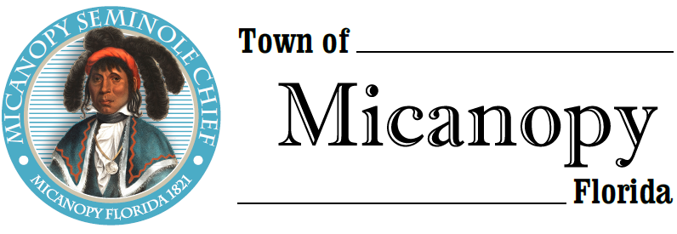
Town of Micanopy
Town Commission • Special Meeting
Applicant Interviews via Virtual Conferencing
Monday • April 26, 2021 • 6:00 PM
_____________________________________________________________________________________________
A G E N D A
1. Call to Order

2. Invocation & Pledge of Allegiance to Flag

3. Roll Call

4. Agenda Approval

5. Town Clerk/Administrator Applicant Interviews: Questions to be asked during the interview process used for the purpose of considering applicants’ qualifications and experience:

1) Tell us why you applied for this position and why you think you will be successful. Where do you see yourself professionally in five years?
2) What do you know about Micanopy and historic preservation?
3) Describe a project that you handled from inception to completion that was most satisfying to you.
4) The job of Micanopy Town Clerk/Administrator is a working administrator position. Describe your governmental accounting and budgeting experience and knowledge of reporting requirements.
5) What are key tasks for a Town Clerk/Administrator? Do you believe that it’s important for the Town Clerk/Administrator to participate or be involved in special events within the Town taking place outside of normal business hours?
6) What can a municipal government do in a time of economic downturn, declining revenue, and a desire to provide consistent levels of service?
7) How and when do you delegate responsibility and authority?
8) Communication to Commissioners, staff, and the public is vital to this position. Please share your current communications skills.
9) Do you possess familiarity of Florida Sunshine Laws?
10) How do you resolve conflict?
11) Citizens are very involved in Micanopy and many have different perspectives. While maintaining objectivity and fairness, describe how you would decide which side to take in a position where two people wanted you to take opposite positions on the same subject.
12) What do you believe are the top three skills the Town Clerk/Administrator should possess?
13) What do you do when an individual Commissioner asks you to perform a task that is not approved by the entire Commission?
14) Based on your education, experience, and background, what do you consider to be your strengths in dealing with local government problems and intergovernmental relations? What are your weaknesses?
15) A function of the Town Clerk/Administrator position is code enforcement. What ability do you possess to interpret, apply, and assist in implementing Micanopy codes, land use policies, ordinances, and regulations?

6. Adjourn Join Zoom Meeting Dial by your location
https://us02web.zoom.us/j/4849692951 +1 301 715 8592 US (Germantown)
+1 312 626 6799 US (Chicago)
Meeting ID: 484 969 2951 +1 929 205 6099 US (New York)
One tap mobile +1 253 215 8782 US (Tacoma)
+13017158592,,4849692951# US (Germantown) +1 346 248 7799 US (Houston)
+13126266799,,4849692951# US (Chicago) +1 669 900 6833 US (San Jose)
Find your local number: https://us02web.zoom.us/u/kGBsr4YJZ

____________________________________________________________________________________________________
PLEASE NOTE: PURSUANT TO SECTION 286.015, FLORIDA STATUTES, IF A PERSON DECIDES TO APPEAL ANY DECISION MADE BY THE COMMISSION WITH RESPECT TO ANY MATTER CONSIDERED DURING THIS MEETING, HE OR SHE WILL NEED TO ENSURE THAT A VERBATIM RECORD OF THE PROCEEDINGS IS MADE, WHICH RECORD INCLUDES THE TESTIMONY AND EVIDENCE UPON WHICH THE APPEAL IS TO BE BASED. IN ACCORDANCE WITH THE AMERICAN WITH DISABILITIES ACT, A PERSON WITH DISABILITIES NEEDING ANY SPECIAL ACCOMODATIONS TO PARTICIPATE IN TOWN MEETINGS SHOULD CONTACT THE TOWN ADMINISTRATOR, 706 NE CHOLOKKA BLVD., MICANOPY, FLORIDA 32667-0137, TELEPHONE (352) 466-3121.

