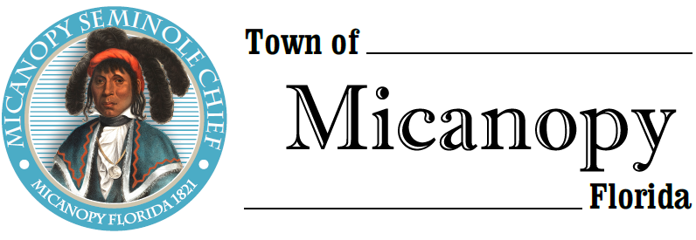
Town of Micanopy
Town Commission • Special Meeting •
Special Election Results – Canvassing Board
Tuesday • June 9, 2020 • 7:00 PM
A G E N D A
_____________________________________________________________________________________________

THE TOWN OF MICANOPY WILL REQUIRE ALL ATTENDEES TO WEAR A FACE MASK. SOCIAL DISTANCING AND ALACHUA COUNTY HEALTH SAFETY GUIDELINES WILL BE FOLLOWED.

1. Call to Order

2. Invocation & Pledge of Allegiance to Flag

3. Roll Call

4. Agenda Approval

5. Upon poll closure, the Town Commission, acting as the Canvassing Board shall take control of the ballot box from the poll workers, shall canvas the return as certified by the Town Clerk, and shall declare the result of the election.

6. Adjourn

________________________________________________________________________________________________________

PLEASE NOTE: PURSUANT TO SECTION 286.015, FLORIDA STATUTES, IF A PERSON DECIDES TO APPEAL ANY DECISION MADE BY THE COMMISSION WITH RESPECT TO ANY MATTER CONSIDERED DURING THIS MEETING, HE OR SHE WILL NEED TO ENSURE THAT A VERBATIM RECORD OF THE PROCEEDINGS IS MADE, WHICH RECORD INCLUDES THE TESTIMONY AND EVIDENCE UPON WHICH THE APPEAL IS TO BE BASED. IN ACCORDANCE WITH THE AMERICAN WITH DISABILITIES ACT, A PERSON WITH DISABILITIES NEEDING ANY SPECIAL ACCOMODATIONS TO PARTICIPATE IN TOWN MEETINGS SHOULD CONTACT THE TOWN ADMINISTRATOR, 706 NE CHOLOKKA BLVD., MICANOPY, FLORIDA 32667-0137, TELEPHONE (352) 466-3121.

