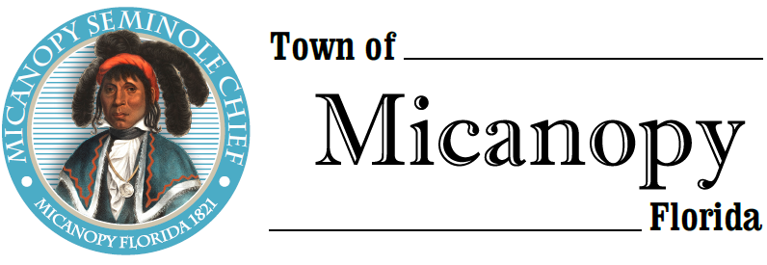
Town of Micanopy
Town Commission • Special Meeting
Dollar General/Concept Companies Stakeholder Meeting
Tuesday • April 6, 2021 • 6:30 PM
At Micanopy Christian Fellowship Church
4909 SE Tuscawilla Road (SE 165th Avenue)
Micanopy, FL 32667

_____________________________________________________________________________________________

A G E N D A
THE TOWN OF MICANOPY WILL REQUIRE ALL ATTENDEES TO WEAR A FACE MASK. SOCIAL DISTANCING AND ALACHUA COUNTY HEALTH SAFETY GUIDELINES WILL BE FOLLOWED.

1. Call to Order

2. Invocation & Pledge of Allegiance to Flag

3. Roll Call

4. Agenda Approval

5. Dollar General/Concept Companies Stakeholder Meeting
Stakeholder meeting to address the issues of the architectural design, lighting, mitigation and building orientation

6. Adjourn

________________________________________________________________________________________________________

PLEASE NOTE: PURSUANT TO SECTION 286.015, FLORIDA STATUTES, IF A PERSON DECIDES TO APPEAL ANY DECISION MADE BY THE COMMISSION WITH RESPECT TO ANY MATTER CONSIDERED DURING THIS MEETING, HE OR SHE WILL NEED TO ENSURE THAT A VERBATIM RECORD OF THE PROCEEDINGS IS MADE, WHICH RECORD INCLUDES THE TESTIMONY AND EVIDENCE UPON WHICH THE APPEAL IS TO BE BASED. IN ACCORDANCE WITH THE AMERICAN WITH DISABILITIES ACT, A PERSON WITH DISABILITIES NEEDING ANY SPECIAL ACCOMODATIONS TO PARTICIPATE IN TOWN MEETINGS SHOULD CONTACT THE TOWN ADMINISTRATOR, 706 NE CHOLOKKA BLVD., MICANOPY, FLORIDA 32667-0137, TELEPHONE (352) 466-3121.

