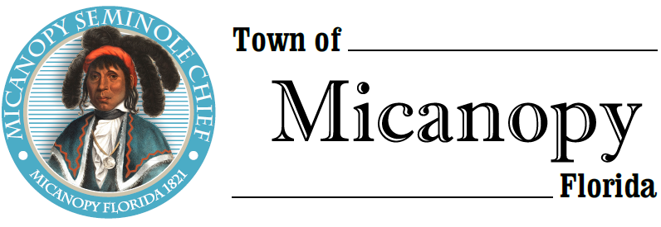
Town of Micanopy
Town Commission • Special Meeting • Via Virtual Conferencing
Alachua County Growth Management - CRS Micanopy 9,100 sq. ft. Retail Store (Parcel #16496-004-000)
Thursday • June 18, 2020 • 6:00 PM
_____________________________________________________________________________________________

A G E N D A

1. Call to Order

2. Invocation & Pledge of Allegiance to Flag

3. Roll Call

4. Agenda Approval

5. Alachua County Growth Management – CRS Micanopy 9,100 sq. ft. Retail Store (Parcel #16496-004-000)
Public Comment (Use Zoom meeting below
or you may email townhall@micanopytown.com in advance of the meeting)

A) Impact to Adjacent Conservation, Cultural, Historical & Archaeological Sites
1) Hwy. 441 Florida Scenic Highway
2) Micanopy Native American Heritage Preserve
3) Alachua Conservation Trust’s Tuscawilla Preserve
4) 1836 Battle of Micanopy (US Army & Seminole) Battlefield Site
B) Impact to Town of Micanopy
1) Increased Traffic
2) Increased Litter & Debris
3) Increased Risk of Pedestrian/Bicycle Accidents
4) Increase in Loss of Wildlife & Wildlife Habitat
5) Impact Through Use of Commercial Lighting
6) Loss of Rural Aesthetic Value
C) Letter to Alachua County Growth Management & BoCC Opposing Development of the Site for Large Commercial Retail Store

6. Adjourn

Join Zoom Meeting
https://us02web.zoom.us/j/4849692951 Dial by your location
+1 301 715 8592 US (Germantown)
+1 312 626 6799 US (Chicago)
One tap mobile +1 929 205 6099 US (New York)
+13017158592,,4849692951# US (Germantown) +1 253 215 8782 US (Tacoma)
+13126266799,,4849692951# US (Chicago) +1 346 248 7799 US (Houston)
+1 669 900 6833 US (San Jose)
Meeting ID: 484 969 2951 Find your local number: https://us02web.zoom.us/u/kdBFQf6M7Z _______________________________________________________________________________________________________
PLEASE NOTE: PURSUANT TO SECTION 286.015, FLORIDA STATUTES, IF A PERSON DECIDES TO APPEAL ANY DECISION MADE BY THE COMMISSION WITH RESPECT TO ANY MATTER CONSIDERED DURING THIS MEETING, HE OR SHE WILL NEED TO ENSURE THAT A VERBATIM RECORD OF THE PROCEEDINGS IS MADE, WHICH RECORD INCLUDES THE TESTIMONY AND EVIDENCE UPON WHICH THE APPEAL IS TO BE BASED. IN ACCORDANCE WITH THE AMERICAN WITH DISABILITIES ACT, A PERSON WITH DISABILITIES NEEDING ANY SPECIAL ACCOMODATIONS TO PARTICIPATE IN TOWN MEETINGS SHOULD CONTACT THE TOWN ADMINISTRATOR, 706 NE CHOLOKKA BLVD., MICANOPY, FLORIDA 32667-0137, TELEPHONE (352) 466-3121.

