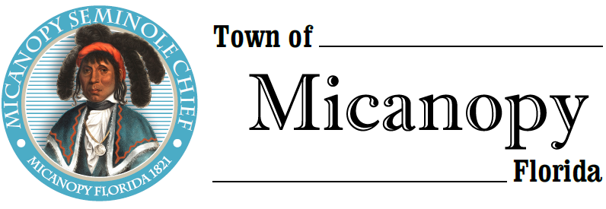
Town of Micanopy
• Special Meeting •
Resolution 2019-12 Fee Schedule
Monday • August 26, 2019 • 6:00 PM
_____________________________________________________________________________________________

A G E N D A

1. Call to Order

2. Invocation & Pledge of Allegiance to Flag

3. Roll Call

4. Agenda Approval

5. Resolution 2019-12 Fee Schedule

6. Adjourn

PLEASE NOTE: PURSUANT TO SECTION 286.015, FLORIDA STATUTES, IF A PERSON DECIDES TO APPEAL ANY DECISION MADE BY THE COMMISSION WITH RESPECT TO ANY MATTER CONSIDERED DURING THIS MEETING, HE OR SHE WILL NEED TO ENSURE THAT A VERBATIM RECORD OF THE PROCEEDINGS IS MADE, WHICH RECORD INCLUDES THE TESTIMONY AND EVIDENCE UPON WHICH THE APPEAL IS TO BE BASED. IN ACCORDANCE WITH THE AMERICAN WITH DISABILITIES ACT, A PERSON WITH DISABILITIES NEEDING ANY SPECIAL ACCOMODATIONS TO PARTICIPATE IN TOWN MEETINGS SHOULD CONTACT THE TOWN ADMINISTRATOR, 706 NE CHOLOKKA BLVD., MICANOPY, FLORIDA 32667-0137, TELEPHONE (352) 466-3121.

