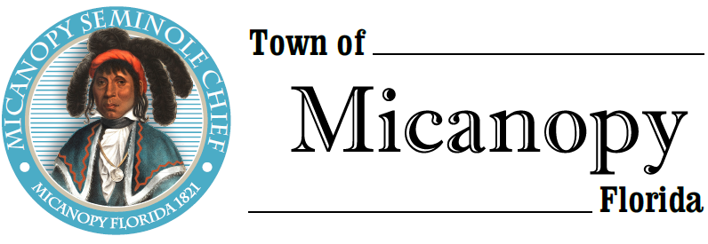
Town of Micanopy
Town Commission • Workshop
Engineering Project Workshop
Tuesday • February 18, 2020 • 6:00 PM
___________________________________________________________________________________________________________

A G E N D A

- Call to Order

2. Invocation & Pledge of Allegiance to Flag

3. Roll Call

4. Agenda Approval

5. Engineering Projects Priority List
A) George F. Young, Inc. Service Line
B) Micanopy Projects (in no specific order of priority)
1) Firehouse Renovations
2) FRDAP Recreation Grant: Basketball Court
3) Street Paving
4) Historic Jail Renovation
5) Water Plant Filtration System
6) Other Projects

6. Adjourn

____________________________________________________________________________________________________________________________________________________________________________________

PLEASE NOTE: PURSUANT TO SECTION 286.015, FLORIDA STATUTES, IF A PERSON DECIDES TO APPEAL ANY DECISION MADE BY THE COMMISSION WITH RESPECT TO ANY MATTER CONSIDERED DURING THIS MEETING, HE OR SHE WILL NEED TO ENSURE THAT A VERBATIM RECORD OF THE PROCEEDINGS IS MADE, WHICH RECORD INCLUDES THE TESTIMONY AND EVIDENCE UPON WHICH THE APPEAL IS TO BE BASED. IN ACCORDANCE WITH THE AMERICAN WITH DISABILITIES ACT, A PERSON WITH DISABILITIES NEEDING ANY SPECIAL ACCOMODATIONS TO PARTICIPATE IN TOWN MEETINGS SHOULD CONTACT THE TOWN ADMINISTRATOR, 706 NE CHOLOKKA BLVD., MICANOPY, FLORIDA 32667-0137, TELEPHONE (352) 466-3121.

