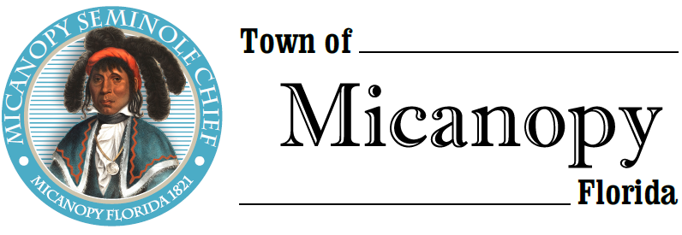
Town of Micanopy
Town Commission • Workshop via Virtual Conferencing
Infrastructure Improvements
Tuesday • October 20, 2020 • 7:00 PM or Upon Completion of LDC Workshop
___________________________________________________________________________________________________________

A G E N D A

- Call to Order

2. Invocation & Pledge of Allegiance to Flag

3. Roll Call

4. Agenda Approval

5. Infrastructure Improvements
A) Water System
B) Sewer System
C) Streets
D) Fire House

6. Adjourn

Join Zoom Meeting Dial by your location
https://us02web.zoom.us/j/4849692951 +1 301 715 8592 US (Germantown)
+1 312 626 6799 US (Chicago)
Meeting ID: 484 969 2951 +1 929 205 6099 US (New York)
One tap mobile +1 253 215 8782 US (Tacoma)
+13017158592,,4849692951# US (Germantown) +1 346 248 7799 US (Houston)
+13126266799,,4849692951# US (Chicago) +1 669 900 6833 US (San Jose)
Find your local number: https://us02web.zoom.us/u/kdBFQf6M7Z

____________________________________________________________________________________________________________________________________________________________________________________

PLEASE NOTE: PURSUANT TO SECTION 286.015, FLORIDA STATUTES, IF A PERSON DECIDES TO APPEAL ANY DECISION MADE BY THE COMMISSION WITH RESPECT TO ANY MATTER CONSIDERED DURING THIS MEETING, HE OR SHE WILL NEED TO ENSURE THAT A VERBATIM RECORD OF THE PROCEEDINGS IS MADE, WHICH RECORD INCLUDES THE TESTIMONY AND EVIDENCE UPON WHICH THE APPEAL IS TO BE BASED. IN ACCORDANCE WITH THE AMERICAN WITH DISABILITIES ACT, A PERSON WITH DISABILITIES NEEDING ANY SPECIAL ACCOMODATIONS TO PARTICIPATE IN TOWN MEETINGS SHOULD CONTACT THE TOWN ADMINISTRATOR, 706 NE CHOLOKKA BLVD., MICANOPY, FLORIDA 32667-0137, TELEPHONE (352) 466-3121.

