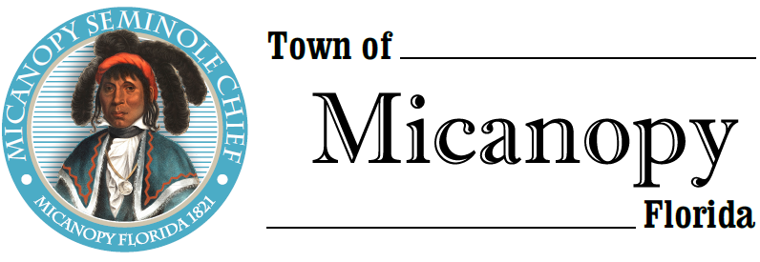

Town Commission • Workshop
Fire Station Renovation
Tuesday • June 18, 2019 • 6:30 PM
___________________________________________________________________________________________________________

A G E N D A

- Call to Order

2. Invocation & Pledge of Allegiance to Flag

3. Roll Call

4. Agenda Approval

5. Fire Station Renovation
A) Architect Building Renovation Draft
B) Architect Opinion of Probable Cost
C) Procedure for Obtaining Professional Services and the Building Process
D) Allocation of Funds and Other Upcoming Financial Obligations
E) Addressing Immediate Needs
F) Other

6. Adjourn

PLEASE NOTE: PURSUANT TO SECTION 286.015, FLORIDA STATUTES, IF A PERSON DECIDES TO APPEAL ANY DECISION MADE BY THE COMMISSION WITH RESPECT TO ANY MATTER CONSIDERED DURING THIS MEETING, HE OR SHE WILL NEED TO ENSURE THAT A VERBATIM RECORD OF THE PROCEEDINGS IS MADE, WHICH RECORD INCLUDES THE TESTIMONY AND EVIDENCE UPON WHICH THE APPEAL IS TO BE BASED. IN ACCORDANCE WITH THE AMERICAN WITH DISABILITIES ACT, A PERSON WITH DISABILITIES NEEDING ANY SPECIAL ACCOMODATIONS TO PARTICIPATE IN TOWN MEETINGS SHOULD CONTACT THE TOWN ADMINISTRATOR, 706 NE CHOLOKKA BLVD., MICANOPY, FLORIDA 32667-0137, TELEPHONE (352) 466-3121.

