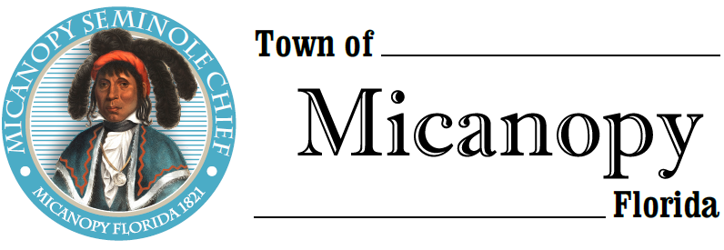
Town of Micanopy
Town Commission • Workshop • Via Virtual Conferencing
Social Media
Tuesday • June 16, 2020 • 6:00 PM
___________________________________________________________________________________________________________

A G E N D A

- Call to Order

2. Invocation & Pledge of Allegiance to Flag

3. Roll Call

4. Agenda Approval

5. Social Media: A discussion of social media as a means of communicating with Micanopy residents
Public Comment (Use Zoom meeting below or you may email townhall@micanopytown.com in advance of the meeting)

6. Adjourn

Join Zoom Meeting
https://us02web.zoom.us/j/4849692951

One tap mobile
+13017158592,,4849692951# US (Germantown)
+13126266799,,4849692951# US (Chicago)

Dial by your location
+1 301 715 8592 US (Germantown)
+1 312 626 6799 US (Chicago)
+1 929 205 6099 US (New York)
+1 253 215 8782 US (Tacoma)
+1 346 248 7799 US (Houston)
+1 669 900 6833 US (San Jose)
Meeting ID: 484 969 2951
Find your local number: https://us02web.zoom.us/u/kdBFQf6M7Z

________________________________________________________________________________________________________________________________________________________________

PLEASE NOTE: PURSUANT TO SECTION 286.015, FLORIDA STATUTES, IF A PERSON DECIDES TO APPEAL ANY DECISION MADE BY THE COMMISSION WITH RESPECT TO ANY MATTER CONSIDERED DURING THIS MEETING, HE OR SHE WILL NEED TO ENSURE THAT A VERBATIM RECORD OF THE PROCEEDINGS IS MADE, WHICH RECORD INCLUDES THE TESTIMONY AND EVIDENCE UPON WHICH THE APPEAL IS TO BE BASED. IN ACCORDANCE WITH THE AMERICAN WITH DISABILITIES ACT, A PERSON WITH DISABILITIES NEEDING ANY SPECIAL ACCOMODATIONS TO PARTICIPATE IN TOWN MEETINGS SHOULD CONTACT THE TOWN ADMINISTRATOR, 706 NE CHOLOKKA BLVD., MICANOPY, FLORIDA 32667-0137, TELEPHONE (352) 466-3121.

