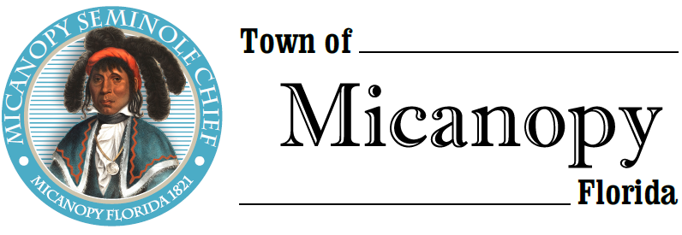
Planning & Historic Preservation Board
Regularly Scheduled Meeting
Tuesday • April 27, 2021 • 7:00 pm
-------------------------------------------------------------------------------------------------------------------------------------------------------
A G E N D A
THE TOWN OF MICANOPY WILL REQUIRE ALL ATTENDEES TO WEAR A FACE MASK. SOCIAL DISTANCING AND ALACHUA COUNTY HEALTH SAFETY GUIDELINES WILL BE FOLLOWED.

1. Call to Order

2. Invocation & Pledge of Allegiance to Flag

3. Roll Call

4. Consent Agenda
1) Agenda Approval
2) Minutes of Regular Meeting March 30, 2021

5. Citizen’s Forum

6. Public Hearings

7. New Business
- Bicentennial Celebration
- Non-Conforming Parcels (less than ½ acre) Discussion
- Sun Dial & Trash Receptacles Downtown Medians

8. Unfinished Business
- Speeding on Tuscawilla Road and Seminary Ave

9. Board Member Comments
• Marian Baron (Seat 1)
- Ann B. Baird (Seat 2)
- Stephen (Dakota) Johnson (Seat 3)
- Stephen Elder (Seat 5)

10. Chair Fro Warren (Seat 4) Report

- Adjournment

__________________________________________________________________________________________________________
PLEASE NOTE: PURSUANT TO SECTION 286.015, FLORIDA STATUTES, IF A PERSON DECIDES TO APPEAL ANY DECISION MADE BY THE BOARD WITH RESPECT TO ANY MATTER CONSIDERED DURING THIS MEETING, HE OR SHE WILL NEED TO ENSURE THAT A VERBATIM RECORD OF THE PROCEEDINGS IS MADE, WHICH RECORD INCLUDES THE TESTIMONY AND EVIDENCE UPON WHICH THE APPEAL IS TO BE BASED. IN ACCORDANCE WITH THE AMERICAN WITH DISABILITIES ACT, A PERSON WITH DISABILITIES NEEDING ANY SPECIAL ACCOMODATIONS TO PARTICIPATE IN TOWN MEETINGS SHOULD CONTACT THE TOWN ADMINISTRATOR, 706 NE CHOLOKKA BLVD., MICANOPY, FLORIDA 32667-0137, TELEPHONE (352) 466-3121.

