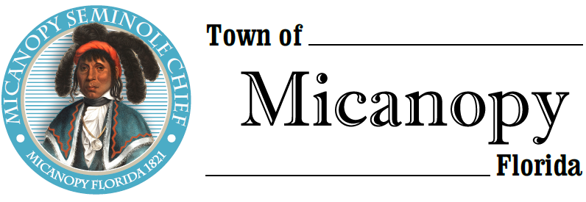

Planning & Historic Preservation Board
Regularly Scheduled Meeting
Tuesday <> December 17, 2019 <> 7:00 pm

_________________________
__________________________________________________________________

AGENDA
1. Call to Order:

2. Invocation & Pledge of Allegiance to Flag:

3. Roll Call:
Board Members
Ann Baird, Vice Chair -- Present/Absent
Tom Brady -- Present/Absent
David Massey -- Present/Absent
Fro Warren, Chair -- Present/Absent
H. Grace Fuller -- Present/Absent

Town Attorney Parker -- Present/Absent
Patty Polk, Deputy Town Clerk -- Present/Absent

4. Swearing in of new board member – Dakota Johnson

5. Agenda Approval:

6. Approval of Previous Meeting Minutes:
- November 19, 2019 - Regular Called Meeting Minutes

7. Citizen’s Forum (Public comments, limit 5 minutes per speaker, please)

8. Public Hearings:

9. New Business:

10. Old Business:
- Town entrance triangle on NW Seminary Ave and Co Rd 234
- Accessory Building & Recommendations
- Airbnb/Short-term rentals- Discussion
- Bicentennial Celebration 2021
- Micanopy Cemetery Lots

11. Board Member Comments:
- Chair report:

12. Adjournment:

