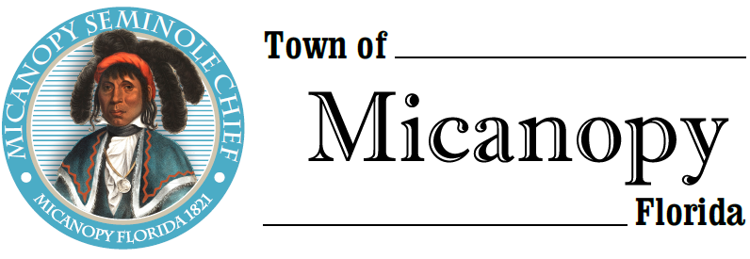
Planning & Historic Preservation Board
Regularly Scheduled Meeting
Tuesday • February 23, 2021 • 7:00 pm
-------------------------------------------------------------------------------------------------------------------------------------------------------
A G E N D A
THE TOWN OF MICANOPY WILL REQUIRE ALL ATTENDEES TO WEAR A FACE MASK. SOCIAL DISTANCING AND ALACHUA COUNTY HEALTH SAFETY GUIDELINES WILL BE FOLLOWED.

1. Call to Order

2. Invocation & Pledge of Allegiance to Flag

3. Roll Call

4. Consent Agenda
1) Agenda Approval
2) Minutes of Regular Meeting January 26, 2021

5. Organizational Meeting: Vote for Chair and Vice Chair

6. Citizen’s Forum

7. Public Hearings
- Action: Lot Split
Parcel: 16644-000-000
Location: 201 & 203 NE Tahota Ave, Micanopy, FL 32667
Owner: Raquel Vallejo

8. New Business
- Fire Station Roof Color – Bronze

9. Unfinished Business
- Speeding on Tuscawilla Road and Seminary Ave – 4 way stop NW Seminary Ave/Division St

10. Board Member Comments
• Marian Baron (Seat 1)
- Ann B. Baird (Seat 2)
- Stephen (Dakota) Johnson (Seat 3)
- Stephen Elder (Seat 5)

- Chair Fro Warren (Seat 4) Report

- Adjournment

__________________________________________________________________________________________________________
PLEASE NOTE: PURSUANT TO SECTION 286.015, FLORIDA STATUTES, IF A PERSON DECIDES TO APPEAL ANY DECISION MADE BY THE BOARD WITH RESPECT TO ANY MATTER CONSIDERED DURING THIS MEETING, HE OR SHE WILL NEED TO ENSURE THAT A VERBATIM RECORD OF THE PROCEEDINGS IS MADE, WHICH RECORD INCLUDES THE TESTIMONY AND EVIDENCE UPON WHICH THE APPEAL IS TO BE BASED. IN ACCORDANCE WITH THE AMERICAN WITH DISABILITIES ACT, A PERSON WITH DISABILITIES NEEDING ANY SPECIAL ACCOMODATIONS TO PARTICIPATE IN TOWN MEETINGS SHOULD CONTACT THE TOWN ADMINISTRATOR, 706 NE CHOLOKKA BLVD., MICANOPY, FLORIDA 32667-0137, TELEPHONE (352) 466-3121.

