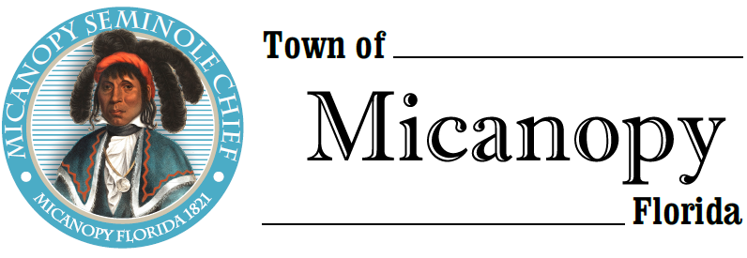

Planning & Historic Preservation Board
Regularly Scheduled Meeting
Tuesday <> February 25, 2020 <> 7:00 pm
A G E N D A
________________________________________________________________________

1. Call to Order:

2. Invocation & Pledge of Allegiance to Flag:

3. Roll Call:
Board Members
Ann Baird, Vice Chair -- Present/Absent
Marion Baron -- Present/Absent
Stephen “Dakota” Johnson -- Present/Absent
Fro Warren, Chair -- Present/Absent
H. Grace Fuller -- Present/Absent

Town Attorney Parker -- Present/Absent
Patty Polk, Deputy Town Clerk -- Present/Absent

4. Agenda Approval:

5. Approval of Previous Meeting Minutes:
- January 28, 2020 - Regular Called Meeting Minutes

6. Citizen’s Forum (Public comments, limit 5 minutes per speaker, please)

7. Public Hearings:
- Certificate of Appropriateness – Sign for commercial business
Parcel: 16693-000-000
Location: 302 NE Cholokka Blvd, Micanopy, FL 32667
Owner: Alberta Mountain
Applicant: Gloria Castenholz, Wren Wood Antiques

8. New Business:

9. Old Business:
- Town entrance triangle on NW Seminary Ave and Co Rd 234
- Accessory Building & Recommendations
- Airbnb/Short-term rentals - Discussion
- Bicentennial Celebration 2021
- Micanopy Cemetery Lots

10. Board Member Comments:
- Chair report:

11. Adjournment:

____________________________________________________________________________________
PLEASE NOTE: PURSUANT TO SECTION 286.015, FLORIDA STATUTES, IF A PERSON DECIDES TO APPEAL ANY DECISION MADE BY THE BOARD WITH RESPECT TO ANY MATTER CONSIDERED DURING THIS MEETING, HE OR SHE WILL NEED TO ENSURE THAT A VERBATIM RECORD OF THE PROCEEDINGS IS MADE, WHICH RECORD INCLUDES THE TESTIMONY AND EVIDENCE UPON WHICH THE APPEAL IS TO BE BASED. IN ACCORDANCE WITH THE AMERICAN WITH DISABILITIES ACT, A PERSON WITH DISABILITIES NEEDING ANY SPECIAL ACCOMODATIONS TO PARTICIPATE IN TOWN MEETINGS SHOULD CONTACT THE TOWN ADMINISTRATOR, 706 NE CHOLOKKA BLVD., MICANOPY, FLORIDA 32667-0137,
TELEPHONE (352) 466-3121.

