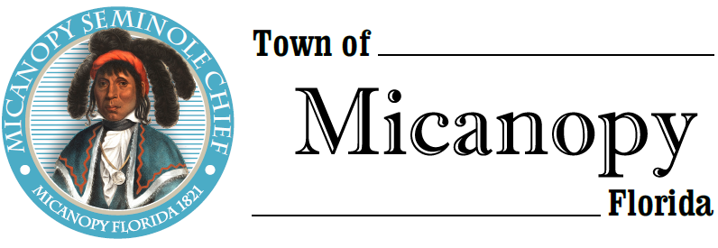
Planning & Historic Preservation Board
Regularly Scheduled Meeting
Tuesday • July 28, 2020 • 7:00 pm
-------------------------------------------------------------------------------------------------------------------------------------------------------
A G E N D A

1. Call to Order

2. Invocation & Pledge of Allegiance to Flag

3. Roll Call

4. Agenda Approval

5. Approval of Previous Meeting Minutes
- February 25, 2020 - Regular Called Meeting Minutes

6. Citizen’s Forum (Use Zoom meeting below or email townhall@micanopytown.com in advance of meeting)

7. Public Hearings
- Variance to build on non-conforming lot – less than 85’ road frontage – has 53’ frontage & Less than ½ acre
Parcel: 16520-018-001
Location: 408 NW Okehumkee St, Micanopy, FL 32667
Owner: Dalo Properties, LLC
Applicant: Giovanni Mazzurco/McKibbon Enterprises Inc.

- Certificate of Appropriateness – Install 22 kw Generator
Parcel: 16682-001-000
Location: 505 NE Cholokka Blvd, Micanopy, FL 32667
Owner: George H. Heslep
Applicant: Trademark Electric

- Variance to build an addition to an existing home – Does not meet required side set back
Parcel: 16520-045-000
Location: 707 NW Eestaulkee Ave, Micanopy, FL
Owner: Lara Colley

8. New Business

9. Unfinished Business
A. LED Street Lights – Discussion

- Board Member Comments

- Chair report

- Adjournment

Join Zoom Meeting Dial by your location
https://us02web.zoom.us/j/4849692951 +1 301 715 8592 US (Germantown)
+1 312 626 6799 US (Chicago)
Meeting ID: 484 969 2951 +1 929 205 6099 US (New York)
One tap mobile +1 253 215 8782 US (Tacoma)
+13017158592,,4849692951# US (Germantown) +1 346 248 7799 US (Houston)
+13126266799,,4849692951# US (Chicago) +1 669 900 6833 US (San Jose)
Find your local number: https://us02web.zoom.us/u/kdBFQf6M7Z
________________________________________________________________________________________________________________
PLEASE NOTE: PURSUANT TO SECTION 286.015, FLORIDA STATUTES, IF A PERSON DECIDES TO APPEAL ANY DECISION MADE BY THE BOARD WITH RESPECT TO ANY MATTER CONSIDERED DURING THIS MEETING, HE OR SHE WILL NEED TO ENSURE THAT A VERBATIM RECORD OF THE PROCEEDINGS IS MADE, WHICH RECORD INCLUDES THE TESTIMONY AND EVIDENCE UPON WHICH THE APPEAL IS TO BE BASED. IN ACCORDANCE WITH THE AMERICAN WITH DISABILITIES ACT, A PERSON WITH DISABILITIES NEEDING ANY SPECIAL ACCOMODATIONS TO PARTICIPATE IN TOWN MEETINGS SHOULD CONTACT THE TOWN ADMINISTRATOR, 706 NE CHOLOKKA BLVD., MICANOPY, FLORIDA 32667-0137, TELEPHONE (352) 466-3121.

