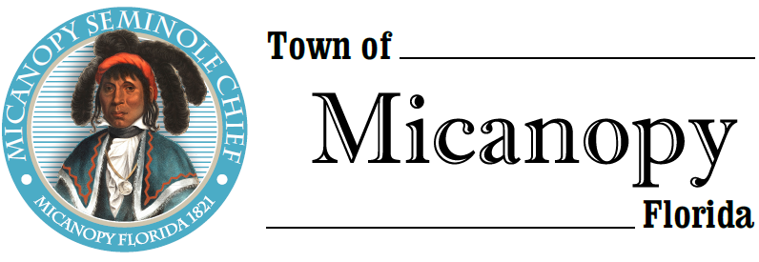
Planning & Historic Preservation Board
Regularly Scheduled Meeting
Tuesday • March 30, 2021 • 7:00 pm
Rescheduled from our March 23, 2021 Meeting
-------------------------------------------------------------------------------------------------------------------------------------------------------
A G E N D A
THE TOWN OF MICANOPY WILL REQUIRE ALL ATTENDEES TO WEAR A FACE MASK. SOCIAL DISTANCING AND ALACHUA COUNTY HEALTH SAFETY GUIDELINES WILL BE FOLLOWED.

1. Call to Order

2. Invocation & Pledge of Allegiance to Flag

3. Roll Call

4. Consent Agenda
1) Agenda Approval
2) Minutes of Regular Meeting February 23, 2021

5. Citizen’s Forum

6. Public Hearings
- Action: Variance to build on a non-conforming lot (less than ½ acre)
Parcel: 16720-028-016
Location: 102 SW 6th St, Micanopy, FL 32667
Owner: Elliot Larkin – Sale Pending

7. New Business
- Joint meeting Town Commission and Planning & Historic Preservation Board – April 6, 2021 – 6:30 pm
Discussion – Dollar General Store
Meeting Location – Micanopy Christian Fellowship Hall, 4909 SE 165th Ave, Micanopy, FL 32667

8. Unfinished Business
- Speeding on Tuscawilla Road and Seminary Ave – 4 way stop NW Seminary Ave/Division St

9. Board Member Comments
• Marian Baron (Seat 1)
- Ann B. Baird (Seat 2)
- Stephen (Dakota) Johnson (Seat 3)
- Stephen Elder (Seat 5)

10. Chair Fro Warren (Seat 4) Report

- Adjournment

__________________________________________________________________________________________________________
PLEASE NOTE: PURSUANT TO SECTION 286.015, FLORIDA STATUTES, IF A PERSON DECIDES TO APPEAL ANY DECISION MADE BY THE BOARD WITH RESPECT TO ANY MATTER CONSIDERED DURING THIS MEETING, HE OR SHE WILL NEED TO ENSURE THAT A VERBATIM RECORD OF THE PROCEEDINGS IS MADE, WHICH RECORD INCLUDES THE TESTIMONY AND EVIDENCE UPON WHICH THE APPEAL IS TO BE BASED. IN ACCORDANCE WITH THE AMERICAN WITH DISABILITIES ACT, A PERSON WITH DISABILITIES NEEDING ANY SPECIAL ACCOMODATIONS TO PARTICIPATE IN TOWN MEETINGS SHOULD CONTACT THE TOWN ADMINISTRATOR, 706 NE CHOLOKKA BLVD., MICANOPY, FLORIDA 32667-0137, TELEPHONE (352) 466-3121.

