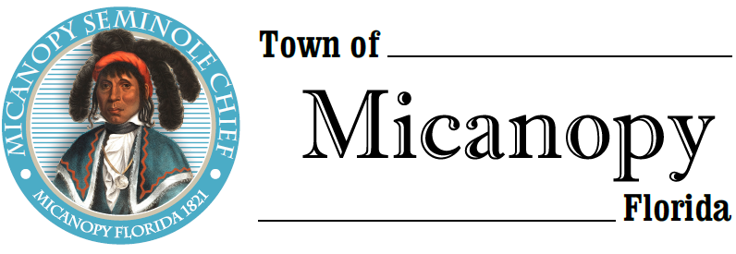
Planning & Historic Preservation Board
Regularly Scheduled Meeting
Tuesday • May 25, 2021 • 7:00 pm
-------------------------------------------------------------------------------------------------------------------------------------------------------
A G E N D A

1. Call to Order

2. Invocation & Pledge of Allegiance to Flag

3. Roll Call

4. Consent Agenda
1) Agenda Approval
2) Minutes of Regular Meeting April 27, 2021

5. Citizen’s Forum

6. Public Hearings

7. New Business
- Alachua County Municipal Code Article XVI-Special Area Plans
- Timing of monthly meeting minutes & agenda

8. Unfinished Business
- Speeding on Tuscawilla Road and Seminary Ave – Speed cam results
- Update: 4-way stop at Division St & Seminary Ave – New motion by Town Commission
- Bicentennial Celebration
- Non-Conforming Parcels (less than ½ acre) Discussion
- Sun Dial Downtown Median
- Dollar General Update

9. Board Member Comments
• Marian Baron (Seat 1)
- Ann B. Baird (Seat 2)
- Stephen (Dakota) Johnson (Seat 3)
- Stephen Elder (Seat 5)

10. Chair Fro Warren (Seat 4) Report

- Adjournment

__________________________________________________________________________________________________________
PLEASE NOTE: PURSUANT TO SECTION 286.015, FLORIDA STATUTES, IF A PERSON DECIDES TO APPEAL ANY DECISION MADE BY THE BOARD WITH RESPECT TO ANY MATTER CONSIDERED DURING THIS MEETING, HE OR SHE WILL NEED TO ENSURE THAT A VERBATIM RECORD OF THE PROCEEDINGS IS MADE, WHICH RECORD INCLUDES THE TESTIMONY AND EVIDENCE UPON WHICH THE APPEAL IS TO BE BASED. IN ACCORDANCE WITH THE AMERICAN WITH DISABILITIES ACT, A PERSON WITH DISABILITIES NEEDING ANY SPECIAL ACCOMODATIONS TO PARTICIPATE IN TOWN MEETINGS SHOULD CONTACT THE TOWN ADMINISTRATOR, 706 NE CHOLOKKA BLVD., MICANOPY, FLORIDA 32667-0137, TELEPHONE (352) 466-3121.

