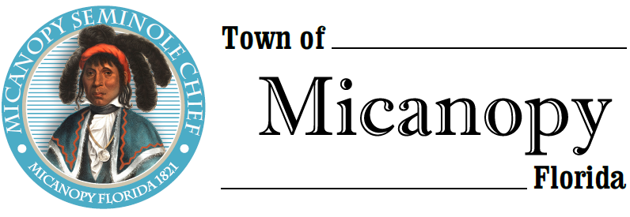

Planning & Historic Preservation Board
Regularly Scheduled Meeting
Tuesday <> November 19, 2019 <> 7:00 pm

_________________________
__________________________________________________________________

AGENDA
1. Call to Order:

2. Invocation & Pledge of Allegiance to Flag:

3. Roll Call:
Board Members
Ann Baird, Vice Chair -- Present/Absent
Tom Brady -- Present/Absent
David Massey -- Present/Absent
Fro Warren, Chair -- Present/Absent
H. Grace Fuller -- Present/Absent

Town Attorney -- Present/Absent
Patty Polk, Deputy Town Clerk -- Present/Absent

4. Agenda Approval:

5. Approval of Previous Meeting Minutes:
- October 22, 2019 - Regular Called Meeting Minutes

6. Citizen’s Forum (Public comments, limit 5 minutes per speaker, please)

7. Public Hearings:
- Action: Certificate of Appropriateness – Decorative Fence
Parcel: 16759-000-000
Location: 103 NE Cholokka Blvd, Micanopy, FL 32667
Owner: Robert C. Lockward – Lost Ark Antiques Inc.

8. New Business:
- Dustin Burch – Land Development Code Violation, Dog Pen Built on Property Line. 202 NE Tahota Ave – 16648-001-000
Discussion
- Cemetery Lots
- Bicentennial Celebration 2021

9. Old Business:
- Town entrance triangle on NW Seminary Ave and Co Rd 234
- Accessory Building & Recommendations
- Airbnb/Short-term rentals- Discussion

10. Board Member Comments:
- Chair report:

11. Adjournment:

