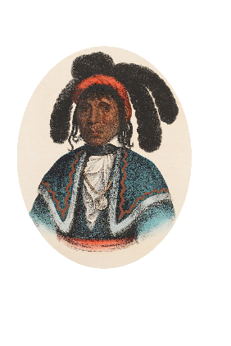 ***Town of Micanopy***

**PO Box 137 • 706 NE Cholokka Blvd**

**Micanopy, Florida 32667-0137**

**Town Hall: 352-466-3121 • Fax: 352-466-4912**

**townhall@micanopytown.com**

**____________________________________________________________________________________________________________**

Application for an Occupational License

Fee $40 each rental unit/space or business

**Please make your check payable to:**

***Town of Micanopy***

*PO Box 137*

*Micanopy, FL 32667-0137*

(This form is NOT a valid license. A separate occupational license is required for each rental location or business.)

**Name of Business   
  
Name of Owner   
  
License Location Street Address:**   
  
**Property Tax Parcel #**:   
  
**License Mailing Address (If Different)   
  
Landlords Indicate Address of Rental Location   
  
Telephone Number   
  
Bustiness Entity Type(Corporation, Sole Prop., LLC, etc.):   
  
Type of Business:   
  
If Other, Please Indicate**