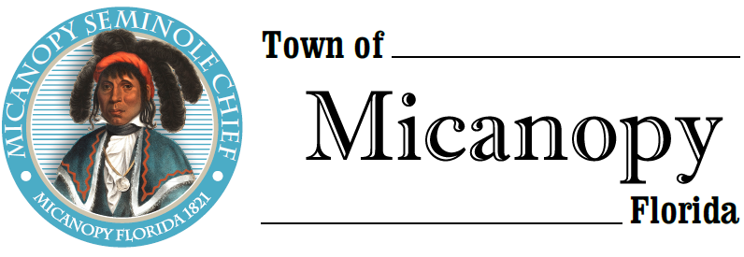

Planning & Historic Preservation Board
Regularly Scheduled Meeting
Tuesday <> October 22, 2019 <> 7:00 pm

_________________________
__________________________________________________________________

AGENDA
1. Call to Order:

2. Invocation & Pledge of Allegiance to Flag:

3. Roll Call:
Board Members
Ann Baird, Vice Chair -- Present/Absent
Tom Brady -- Present/Absent
David Massey -- Present/Absent
Fro Warren, Chair -- Present/Absent
H. Grace Fuller -- Present/Absent

Andrea True Parker, Town Attorney -- Present/Absent
Patty Polk, Deputy Town Clerk -- Present/Absent

4. Agenda Approval:

5. Approval of Previous Meeting Minutes:
- September 24, 2019 - Regular Called Meeting Minutes

6. Citizen’s Forum (Public comments, limit 5 minutes per speaker, please)

7. Public Hearings:

8. New Business

9. Old Business:
- Town entrance triangle on NW Seminary Ave and Co Rd 234
- Accessory Building & Recommendations
- Derelict Building
- Airbnb

10. Board Member Comments:
- Chair report:

11. Adjournment:

