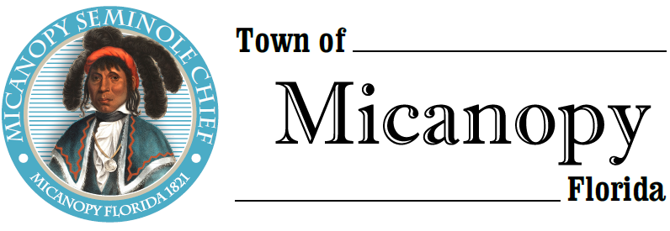
Planning & Historic Preservation Board
Regularly Scheduled Meeting via Virtual Conferencing
Tuesday • October 27, 2020 • 7:00 pm
-------------------------------------------------------------------------------------------------------------------------------------------------------
A G E N D A

1. Call to Order

2. Invocation & Pledge of Allegiance to Flag

3. Roll Call

4. Consent Agenda
1) Agenda Approval
2) Minutes of Regular Meeting September 22, 2020
3) Next Month’s Physical Meeting Scheduled for November 17, 2020

5. Citizen’s Forum (Use Zoom meeting below or email townhall@micanopytown.com in advance of meeting)

6. Public Hearings – None

7. New Business – None

8. Unfinished Business
- Duke Energy LED Lights – Dorothy Pernu & Duane Young
1) Sample Street Light Discussion
2) Micro Street Light Recommendation
- Speeding on Tuscawilla Road and Seminary Ave – Possibility of more stop signs and/or speed humps

9. Board Member Comments
• Marian Baron (Seat 1)
- Ann B. Baird (Seat 2)
- Stephen (Dakota) Johnson (Seat 3)
- Stephen Elder (Seat 5)

- Chair Fro Warren (Seat 4) Report

- Adjournment

Join Zoom Meeting Dial by your location
https://us02web.zoom.us/j/4849692951 +1 301 715 8592 US (Germantown)
+1 312 626 6799 US (Chicago)
Meeting ID: 484 969 2951 +1 929 205 6099 US (New York)
One tap mobile +1 253 215 8782 US (Tacoma)
+13017158592,,4849692951# US (Germantown) +1 346 248 7799 US (Houston)
+13126266799,,4849692951# US (Chicago) +1 669 900 6833 US (San Jose)
Find your local number: https://us02web.zoom.us/u/kdBFQf6M7Z

______________________________________________________________________________________________________________
PLEASE NOTE: PURSUANT TO SECTION 286.015, FLORIDA STATUTES, IF A PERSON DECIDES TO APPEAL ANY DECISION MADE BY THE BOARD WITH RESPECT TO ANY MATTER CONSIDERED DURING THIS MEETING, HE OR SHE WILL NEED TO ENSURE THAT A VERBATIM RECORD OF THE PROCEEDINGS IS MADE, WHICH RECORD INCLUDES THE TESTIMONY AND EVIDENCE UPON WHICH THE APPEAL IS TO BE BASED. IN ACCORDANCE WITH THE AMERICAN WITH DISABILITIES ACT, A PERSON WITH DISABILITIES NEEDING ANY SPECIAL ACCOMODATIONS TO PARTICIPATE IN TOWN MEETINGS SHOULD CONTACT THE TOWN ADMINISTRATOR, 706 NE CHOLOKKA BLVD., MICANOPY, FLORIDA 32667-0137, TELEPHONE (352) 466-3121.

