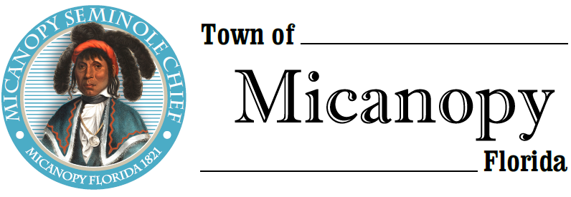
Town of Micanopy
Posted Event
Willie Mae Stokes Community Center Prayer March
Saturday • July 11, 2020 • 10:00AM-12:00 Noon
___________________________________________________________________________________________________________

POSTED EVENT

Christopher Stokes, CEO of The Willie Mae Stokes Community Center invited elected officials and the public to participate in a Prayer Walk on July 11, 2020 from 10:00am-Noon. Mayor Aufmuth, Commissioner Roberts, and Commissioner Blakely participated in the event. The Prayer Walk began at The Willie Mae Stokes Community Center at 355 NW Eestaulustee Avenue and ended in prayer at the Friends of the Micanopy Library Gazebo at 308 NE Cholokka Blvd. Because of COVID-19 concerns and Alachua County’s Emergency Amendments, participants were encouraged to wear a face mask and practice social distancing.

____________________________________________________________________________________________________________________________________________________________________________________

PLEASE NOTE: PURSUANT TO SECTION 286.015, FLORIDA STATUTES, IF A PERSON DECIDES TO APPEAL ANY DECISION MADE BY THE COMMISSION WITH RESPECT TO ANY MATTER CONSIDERED DURING THIS MEETING, HE OR SHE WILL NEED TO ENSURE THAT A VERBATIM RECORD OF THE PROCEEDINGS IS MADE, WHICH RECORD INCLUDES THE TESTIMONY AND EVIDENCE UPON WHICH THE APPEAL IS TO BE BASED. IN ACCORDANCE WITH THE AMERICAN WITH DISABILITIES ACT, A PERSON WITH DISABILITIES NEEDING ANY SPECIAL ACCOMODATIONS TO PARTICIPATE IN TOWN MEETINGS SHOULD CONTACT THE TOWN ADMINISTRATOR, 706 NE CHOLOKKA BLVD., MICANOPY, FLORIDA 32667-0137, TELEPHONE (352) 466-3121.

