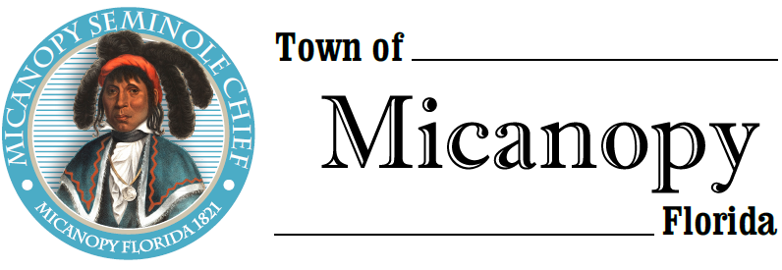
Town of Micanopy
Posted Event
Willie Mae Stokes Community Center Mural Celebration
Saturday • December 5, 2020 • 1:00PM-4:00 PM
___________________________________________________________________________________________________________

POSTED EVENT

Christopher Stokes, CEO of The Willie Mae Stokes Community Center has invited elected officials and the public to participate in a Mural Dedication on Saturday, December 5, 2020 from 1:00pm-4:00pm. Two or more commissioners may attend. The Celebration will be held at The Willie Mae Stokes Community Center at 355 NW Eestaulustee Avenue from 1:00pm-4:00pm. Because of COVID-19 concerns and Alachua County’s Emergency Amendments, participants are encouraged to wear a face mask and practice social distancing.

____________________________________________________________________________________________________________________________________________________________________________________

PLEASE NOTE: PURSUANT TO SECTION 286.015, FLORIDA STATUTES, IF A PERSON DECIDES TO APPEAL ANY DECISION MADE BY THE COMMISSION WITH RESPECT TO ANY MATTER CONSIDERED DURING THIS MEETING, HE OR SHE WILL NEED TO ENSURE THAT A VERBATIM RECORD OF THE PROCEEDINGS IS MADE, WHICH RECORD INCLUDES THE TESTIMONY AND EVIDENCE UPON WHICH THE APPEAL IS TO BE BASED. IN ACCORDANCE WITH THE AMERICAN WITH DISABILITIES ACT, A PERSON WITH DISABILITIES NEEDING ANY SPECIAL ACCOMODATIONS TO PARTICIPATE IN TOWN MEETINGS SHOULD CONTACT THE TOWN ADMINISTRATOR, 706 NE CHOLOKKA BLVD., MICANOPY, FLORIDA 32667-0137, TELEPHONE (352) 466-3121.

