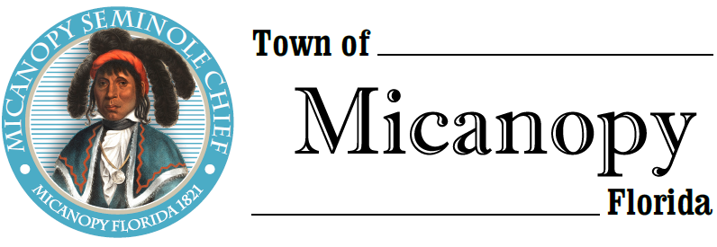
Town of Micanopy
Posted Event
Willie Mae Stokes Community Center Mural Celebration
Saturday • December 5, 2020 • 1:00PM-4:00 PM
Minutes
___________________________________________________________________________________________________________

POSTED EVENT

Christopher Stokes, CEO of The Willie Mae Stokes Community Center invited elected officials and the public to participate in a Mural Dedication on Saturday, December 5, 2020 from 1:00pm-4:00pm. Commissioner Blakely attended the event with approximately 25-30 other attendees. The Celebration was held at The Willie Mae Stokes Community Center at 355 NW Eestaulustee Avenue from 1:00pm-4:00pm. Because of COVID-19 concerns and Alachua County’s Emergency Amendments, participants were encouraged to wear a face mask and practice social distancing.

MINUTES APPROVED:

As submitted ______ as amended _____ at Town Commission Meeting ___________________________________

_______________________________________________ __________________________________________
Joseph L. Aufmuth, Mayor Debbie Gonano, Town Administrator/Clerk

