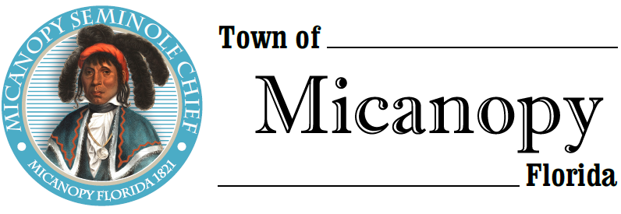
Planning & Historic Preservation Board
Regularly Scheduled Meeting via Virtual Conferencing
Tuesday • September 22, 2020 • 7:00 pm
-------------------------------------------------------------------------------------------------------------------------------------------------------
A G E N D A
1. Call to Order

2. Invocation & Pledge of Allegiance to Flag

3. Roll Call

4. Consent Agenda
1) Agenda Approval
2) Minutes of Regular Meetings of July 28, 2020 & August 25, 2020

5. Citizen’s Forum (Use Zoom meeting below or email townhall@micanopytown.com in advance of meeting)

6. Public Hearings –
Rescheduled Meeting September 1, 2020 (rescheduled due to internet failure)
- Final Site Plan Review – Battery Energy Storage Facility
Parcel: 16799-004-000
Location: 304 NE Hwy 441, Micanopy, FL 32667
Owner: Duke Energy Florida, LLC
Applicant: Dorothy Pernu, Duke Energy Government & Community Relations Manager
Adam Nygaard, Duke Energy Project Manager

- Certificate of Appropriateness – Windows
Parcel: 16746-002-000
Location: 112 NE Hunter Ave, Micanopy, FL 32667
Owner: Stephen Elder

7. New Business
- Speeding on Tuscawilla Road and Seminary Ave – Possibility of more stop signs and/or speed humps

8. Unfinished Business
- Entrance Triangle Seminary Avenue and CR234

9. Board Member Comments
• Marian Baron (Seat 1)
- Ann B. Baird (Seat 2)
- Stephen (Dakota) Johnson (Seat 3)
- Grace Fuller (Seat 5)

- Chair Fro Warren (Seat 4) Report

- Adjournment

Join Zoom Meeting Dial by your location
https://us02web.zoom.us/j/4849692951 +1 301 715 8592 US (Germantown)
+1 312 626 6799 US (Chicago)
Meeting ID: 484 969 2951 +1 929 205 6099 US (New York)
One tap mobile +1 253 215 8782 US (Tacoma)
+13017158592,,4849692951# US (Germantown) +1 346 248 7799 US (Houston)
+13126266799,,4849692951# US (Chicago) +1 669 900 6833 US (San Jose)
Find your local number: https://us02web.zoom.us/u/kdBFQf6M7Z
________________________________________________________________________________________________________________
PLEASE NOTE: PURSUANT TO SECTION 286.015, FLORIDA STATUTES, IF A PERSON DECIDES TO APPEAL ANY DECISION MADE BY THE BOARD WITH RESPECT TO ANY MATTER CONSIDERED DURING THIS MEETING, HE OR SHE WILL NEED TO ENSURE THAT A VERBATIM RECORD OF THE PROCEEDINGS IS MADE, WHICH RECORD INCLUDES THE TESTIMONY AND EVIDENCE UPON WHICH THE APPEAL IS TO BE BASED. IN ACCORDANCE WITH THE AMERICAN WITH DISABILITIES ACT, A PERSON WITH DISABILITIES NEEDING ANY SPECIAL ACCOMODATIONS TO PARTICIPATE IN TOWN MEETINGS SHOULD CONTACT THE TOWN ADMINISTRATOR, 706 NE CHOLOKKA BLVD., MICANOPY, FLORIDA 32667-0137, TELEPHONE (352) 466-3121.

