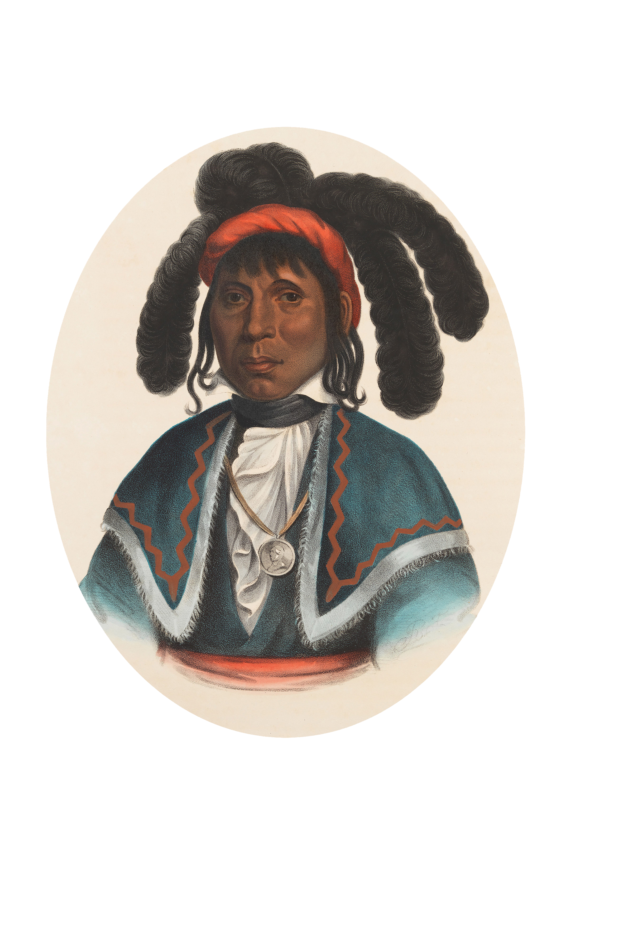
Town of Micanopy
Town Commission
Minutes Special Meeting
Community Development Block Grant (CDBG)
Second Public Hearing
MICANOPY, SEMINOLE CHIEF
Thursday, April 23, 2019 • 5:00 pm

1. Call to Order: 5:00 pm

2. Invocation & Pledge of Allegiance to Flag

3. Roll Call
Commissioners Attending:
- Joseph Aufmuth, Mayor Present
- Tim Parker, Mayor Pro Tem Present
- Ed Burnett Present
- Troy Blakely Present
- Mike Roberts Absent

- Debbie Gonano, Town Administrator Present

4. Agenda Approval:
Motion made and seconded (Blakely/Parker) to approve the agenda as submitted; passed 4-0

5. Community Development Block Grant (CDBG) Neighborhood Revitalization Project – Second Public Hearing
1) Open Second Public Hearing to allow for public input on the application
Presentation on details of the application – David Fox, Fred Fox Enterprises, Inc.
There was no public participation at the meeting. Excluding Commissioners and staff, the only other people present were David Fox and Savannah Kirwan, Kimley-Horn.

Mr. Fox presented details of the CDBG application, which has a submission due date of May 6th. The maximum grant funds for the primary well drilling project is $600,000 broken down as follows: well drilling of $477,000, engineering of $100,000, and administrative costs of $48,000 for a total projected cost of $625,000; with the Town providing matching funds of $25,000. The Department of Economic Opportunity (DEO) requires that all projects be put out for bid.

Application Unmet Needs (in no particular order) - In the event there are no remaining grant funds, or insufficient funds to complete a project, the Town is under no obligation to fund these unmet needs:
1) Water Plant Filtration System – Engineer’s Project Cost Estimate $1,500,000
Installation of a filtration system to remove excess iron and organics from the raw water. Mayor Pro Tem Parker wanted to know how the $1.5 million price tag was computed, as he had gotten costs estimates of $50,000 - $100,000. Savannah Kirwan explained that the engineer cost estimates were conservative and were based on the system’s design flow rate of 518,000 gallons/day, not the current average pump rate of 65,000 gallons/day. Additionally, Savannah explained that without a sanitary sewer system, the costs to dispose of the concentrate brine byproducts produced through use of a filtration system, by use of a drying bed or percolation pond are very expensive. Because of the expected $1.5 million cost and impending due date of the CDBG application, Mayor Aufmuth thought that the filtration option should be eliminated from the application.
Motion made and seconded (Parker/Burnett) to delete Unmet Need #1-03J Water Tank/Well/Water Treatment Plant Improvements from the CDBG application; passed 4-0

2) Water Plant Tank Mixer – Engineer’s Project Cost Estimate $25,000
Installation of a water tank mixer to circulate and blend the finished water in the existing elevated storage tank to prevent the water from becoming stagnant which can decrease the chlorine residual in the tank.

3) Radio-Read Water Meters, Meter Boxes, Etc. – Engineer’s Project Cost Estimate $100,000
Replacement of all existing occupied residential (no commercial) potable water meters with radio-read water meters, meter boxes, curb stops, and backflow preventers; and funding for an automatic meter reader data collector, software, and hardware required to read the water meters and develop the water bills for disbursement.

Motion made and seconded (Parker/Burnett) to approve the application narrative; passed 4-0
The Public Hearing was closed. Three resolutions were presented for consideration:

a) Resolution 2019-03 Authorization to Submit Application
Mayor Aufmuth read Resolution 2019-03 by title only.
Motion made and seconded (Blakely/Parker) to approve submission of the application; passed 4-0
b) Resolution 2019-04 $25,000 Housing Rehabilitation Revenue Leverage
Mayor Aufmuth read Resolution 2019-04 by title only.
Motion made and seconded (Burnett/Parker) to approve the $25,000 leverage; passed 4-0
c) Resolution 2019-05 Community Development Plan
Mayor Aufmuth read Resolution 2019-05 in its entirety.
Motion made and seconded (Blakely/Parker) to approve the Community Development Plan; passed 4-0

6. Adjourn: 5:22 pm

MINUTES APPROVED:

As submitted as amended at Town Commission Meeting

Joseph L. Aufmuth, Mayor Debbie Gonano, Recorder

